DUO coming to Outlook email for faculty and staff on March 27th
We use DUO for our Georgia College (GC) Multi-Factor Authentication (MFA). It is an authentication tool in which a computer user is granted access only after successfully presenting two pieces of evidence (factors); something the user knows (password) and something the user possesses (i.e. phone, smart device, token, etc.).
We have been using DUO successfully for approximately 1 year to protect access to OneUSG, PeopleSoft and several other systems with more to come. DUO will be used to protect and secure Banner Admin (not PAWS) starting March 26th and Outlook Webmail for all of our campus faculty and staff on March 27th.
What to expect starting March 26th:
You should see a DUO prompt each time you login to the Banner Admin pages. This will not impact students or users of the self-service portion of banner we call PAWS.
What to expect starting March 27th:
You should see a DUO prompt each time you login for the following Microsoft Outlook applications:
* Outlook online in a browser: https://outlook.com/gcsu.edu
* Outlook on a MAC Laptop, iPad, iPhone, etc.
* OneDrive on a PC
You may not see a DUO prompt each time when logging in to the following:
* Outlook on a PC
* Mail app on a MAC Laptop, iPad, iPhone, etc. (unless you're setting up a new account as an Exchange account)
* Android Mail
Future Use:
Security is ever increasingly critical as hackers and thieves become more sophisticated and attack users at home and work. GC will continue to protect our community and critical resources with DUO as time and effort permit.
DUO Use and Tips:
Multiple authentication methods:
If you set DUO with only one phone number you could be at risk. What if your phone is out of battery, you do not have signal, you lose your phone, or you forget it at home? How will you get into your email or critical systems protected by DUO? Adding additional phone numbers will allow you to validate your access. Any number that can receive a phone call can be used to validate your log on.
DUO Self Service (available after you log into Unify) allows individual users to add additional devices and authentication methods:
- DUO supports phone calls (to landlines, cell phones, etc.).
- DUO Mobile app (Push, passcode stored in the app, texted passcode) to smart devices (phones and tablets)
- DUO supports hardware tokens or USB keys. We use 2 types of tokens/keys, from Yubico:
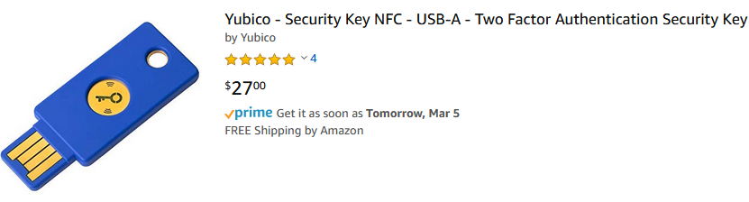
The blue key (above) can be purchased and set up by each individual to their account. It works only with Google Chrome.

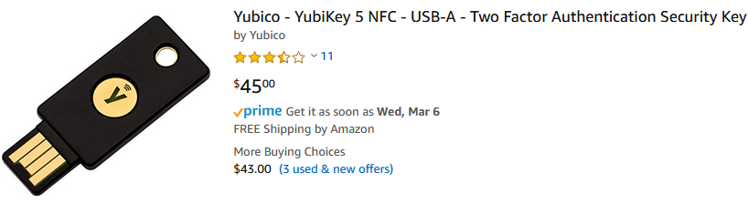
The black key (shown above) can be purchased by the individual or department but must be associated with the individual user through the Serve Help Desk. It works with all browsers.
Both keys above are listed on Amazon. The Innovation Station should have a few available very soon.
Using DUO
Below are detailed instructions on logging into the Duo Portal and adding additional authentication numbers.
When going into DUO Self Service, you’ll be prompted for your Unify/GC user name and password, and then you’ll be required to authenticate using DUO (using your existing authentication methods):

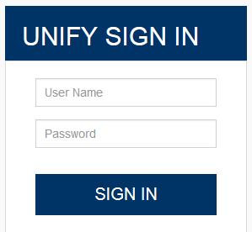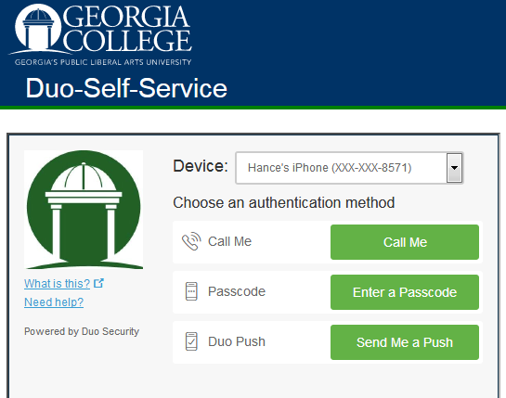

If you’re at the “Choose an authentication method” screen above, you have not yet authenticated into DUO Self Service. It’s only when you see the “My Settings & Devices” screen (shown below) that you’re actually IN the self-service module. You can add, remove or change your device settings to meet your personal needs.
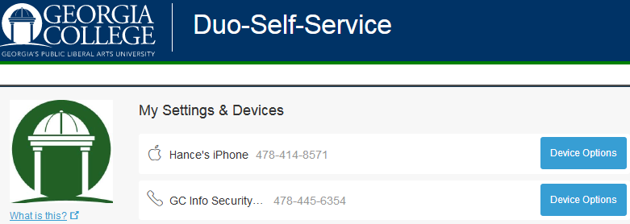

To add an additional device, choose the “+Add additional device” towards the center of the screen. It’ll step you through the process:

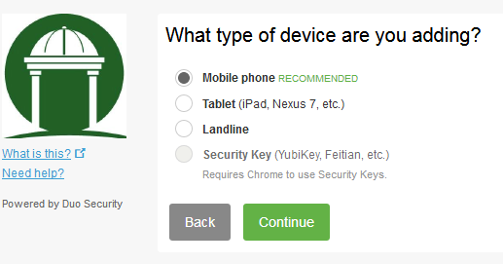

Additional information and detailed instructions for DUO are available on the Human Resources training site: https://training.gcsu.edu/public/programs
If you have additional questions, please contact Hance Patrick at hance.patrick@gcsu.edu or 445-6354.

