ITEM #1
September 8, 2023, BOR Meeting
Board Policy 3.3.1 Core Curriculum

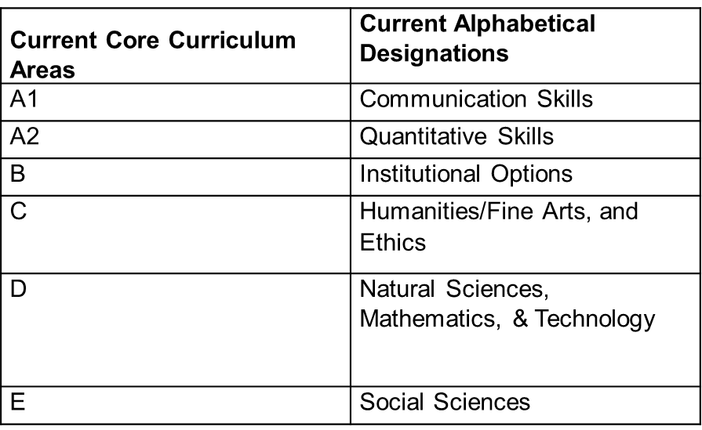

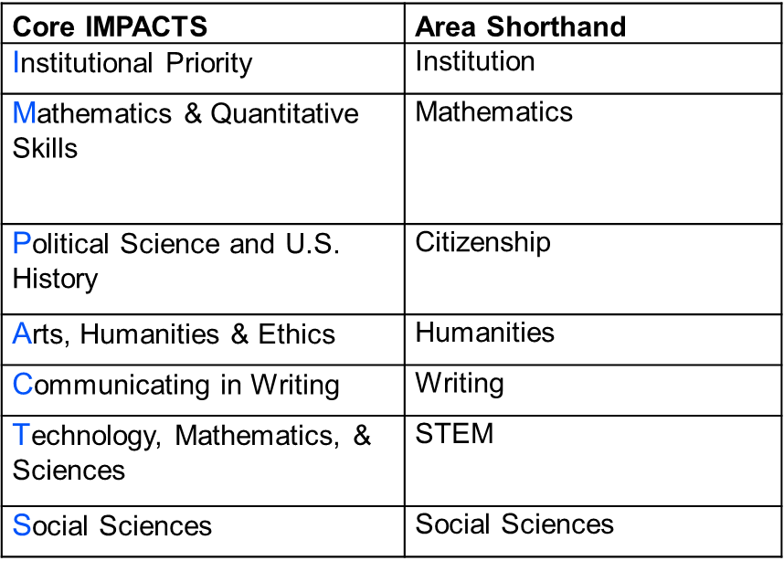

ITEM #2

Institutional oversight
  - Modifications to syllabi (soft launch in Spring 2024)
  - Aligning assessments and other processes

Technological modifications
  - Banner, Degree Works, Program Maps, Catalogs, etc. (implement by Fall 2024)

USG Recommendation (October 2023) to amend Board policy 3.3.1 Core Curriculum, effective immediately, with full implementation by Fall 2024 with changes in the nomenclature of core curriculum areas, and the inclusion of system-wide learning outcomes and career-ready competencies.

ITEM #3

- Multiple constituents: dean/department chair leadership and faculty; general education committee, university senate; registrar/advising/institutional effectiveness, etc.....

- September 12 Meeting.

