SAPC 2025-2026 Attendance
September 5, 2025
2025-2026 SAPC Membership

(P denotes Present, A denotes Absent, R denotes Regrets)
Amy Pinney | P | Kirsten Schipper | P
Phillip Male | P | Ezra Ryall | A
Sarah Whatley | A | David Johnson | P
Cara Smith | P | Matthew Forrest | P
Serena Semere | P | Lamonica Sanford | P
Desaree Henriquez | P | Riley-Kate Miller | A
Guests:

October 3, 2025
SAPC attended SGA’s monthly meeting in lieu of October’s regularly scheduled SAPC meeting.
November (held October 31, 2025)
2025-2026 SAPC Membership

(P denotes Present, A denotes Absent, R denotes Regrets)
Amy Pinney | P | Kirsten Schipper | R
Phillip Male | P | Ezra Ryall | R
Sarah Whatley | P | David Johnson | P
Cara Smith | P | Matthew Forrest | R
Serena Semere | at SGA meeting | Lamonica Sanford | P
Desaree Henriquez | P | Riley-Kate Miller | P
Guests:

December – no meeting

January 9, 2026
2025-2026 SAPC Membership

(P denotes Present, A denotes Absent, R denotes Regrets)
Amy Pinney | P | Kirsten Schipper | P
Phillip Male | P | Ezra Ryall | A
Sarah Whatley | P | David Johnson | P
Cara Smith | P | Matthew Forrest | R
Serena Semere | P | Lamonica Sanford | P
Desaree Henriquez | P | Riley-Kate Miller | A
Guests:

February 13, 2026
2025-2026 SAPC Membership

(P denotes Present, A denotes Absent, R denotes Regrets)
Amy Pinney | P | Kirsten Schipper | P
Phillip Male | R | Ezra Ryall | A
Sarah Whatley | R | David Johnson | P
Cara Smith | P | Matthew Forrest | P
Serena Semere | P | Lamonica Sanford | P
Desaree Henriquez | R | Riley-Kate Miller | A
Guests:

March 6, 2026
2025-2026 SAPC Membership

(P denotes Present, A denotes Absent, R denotes Regrets)
Amy Pinney | P | Kirsten Schipper | P
Phillip Male | P | Ezra Ryall | A
Sarah Whatley | P | David Johnson | P
Cara Smith | P | Matthew Forrest | P
Serena Semere | P | Lamonica Sanford | P
Desaree Henriquez | P | Riley-Kate Miller | P
Guests:

April 3, 2026
<insert here after meeting tomorrow>
Summary:
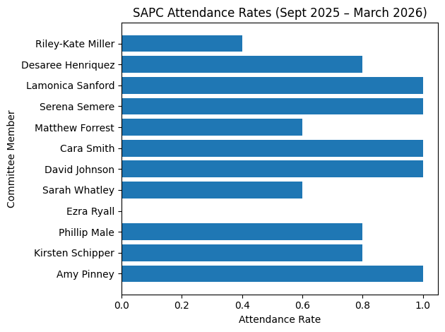
• A value of 1.0 = attended all meetings
• Around 0.8 = missed or sent regrets for one meeting
• Lower values indicate more frequent absences

