**Committee Name:** Executive Committee of University Senate (ECUS) with Standing Committee Chairs (SCC)

**Meeting Date & Time:** Friday, February 14, 2020, 3:30-4:45 p.m.

**Meeting Location:** Parks Hall 301

**Attendance**:

|  |  |
| --- | --- |
| **Members “P” denotes Present, “A” denotes Absent, “R” denotes Regrets** | |
| **P** | Alex Blazer (CoAS, ECUS Chair Emeritus and Secretary) |
| **P** | Hauke Busch (CoAS, ECUS Vice-Chair) |
| **R** | Steve Dorman (University President) |
| **P** | Jeff Dowdy (Library, ECUS Member) |
| **P** | Catherine Fowler (CoHS, ECUS Member) |
| **P** | David Johnson (CoAS, ECUS Chair) |
| **P** | Lyndall Muschell (CoE, ECUS Member) |
| **P** | Costas Spirou (Provost) |
| **P** | John Swinton (CoB, ECUS Member) |
| **P** | Nicole DeClouette (APC Chair) |
| **P** | Matt Forrest (FAPC Chair) |
| **P** | Sabrina Hom (RPIPC Chair) |
| **P** | Angela Criscoe (SAPC Chair) |
| **Guests** | |
| None | |

**Legend**

*Italicized text denotes information from a previous meeting.*

*Denotes new discussion on old business.

Highlighted text denotes follow-up.

**Bold text denotes action or recommendation.**

**I. Call to Order:** The meeting was called to order at 3:31 pm by David Johnson (Chair).

**II. Approval of Agenda:** A **Motion** *to approve the agenda* was made and seconded. **The agenda was approved as circulated.**

**III. Approval of Minutes:** A draft of the 10 Jan 2020 minutes of the Executive Committee with Standing Committee Chairs had been circulated to the meeting attendees via email. A **Motion** to approve the minutes was made and seconded. **The minutes were approved.**

**IV. Reports**

**University President — President Dorman**

1. As President Dorman had extended *Regrets* and was unable to attend this meeting, there was no President’s Report.

**University Provost — Provost Spirou**

1. **General Education**
   1. The USG *General Education Implementation Group* completed its meetings.  A presentation by Dr. Tristan Denley to the BOR on February 11th provided a reconstituted format (link to presentation can be found at [https://youtu.be/8E0x64jk8OE](https://nam03.safelinks.protection.outlook.com/?url=https%3A%2F%2Fyoutu.be%2F8E0x64jk8OE&data=02%7C01%7Ccostas.spirou%40gcsu.edu%7C1cd40b0b679347fc7db808d7b16614de%7Cbfd29cfa8e7142e69abc953a6d6f07d6%7C0%7C0%7C637172924306735991&sdata=kNRsF3X%2B4cjY9sabyjr2Tw1AHqyrd93It4NAIPJM03k%3D&reserved=0). Please feel free to provide feedback through the USG Redesigned General Education portal at <https://www.usg.edu/redesigned_general_education/feedback>.
   2. There are three major elements in the proposed General Education Curriculum.
      1. Core Elements (33 Credit Hours)
         1. These include (Arts & Humanities, Math, History & Government, Social Sciences, Science, Data & Digital Fluency, Written Communication, and Oral Communication). 21st century skills have been identified to be incorporated into those Core Elements. The 21st Century Skills have been packaged in groups as follows:
            1. Critical Thinking + (Critical Thinking, Creative Thinking, Synthesis, Research, Problem Solving)
            2. Global Competencies (Culture & Diversity, Ethics, Global Perspectives, Citizenship)
            3. Information Literacy + (Information Literacy, Technology Skills, Data Literacy)
      2. Field of Study (18 Credit Hours)
      3. Exploratory Courses (9 Credit Hours)

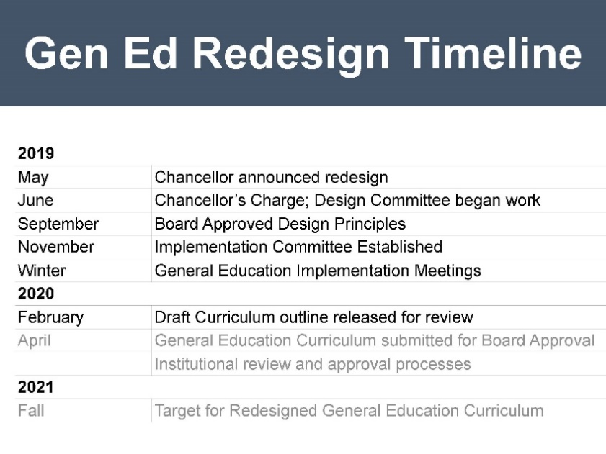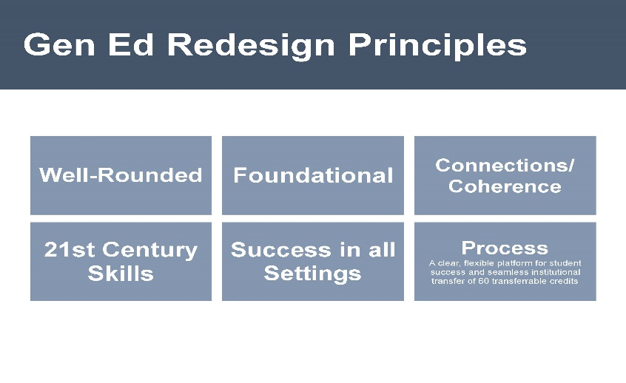



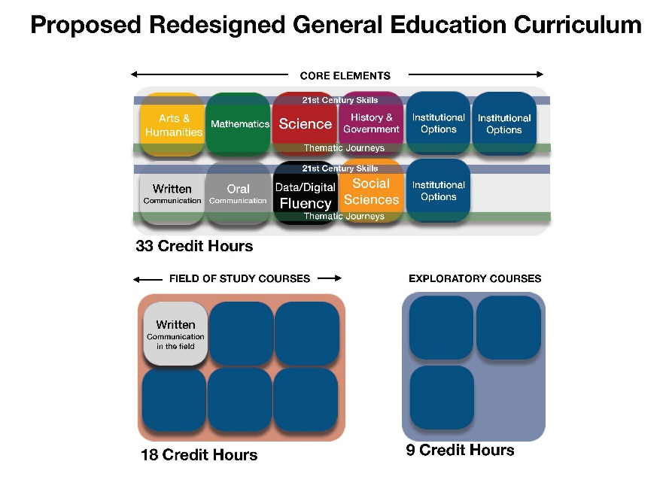

1. **Update – Momentum Summit-III**
   1. On January 28th-29, the University System of Georgia held their 3rd annual Momentum Summit, asking representatives from each USG institution to participate. Georgia College’s Momentum Team included the President’s Cabinet, the Director of Advising, the Director of First Year Experience, the Director of GC Journeys, the Director of Residence Life, the Director of the Center for Teaching and Learning, and the Associate Provost for Transformative Learning Experiences.
   2. On Day 1, Dr. Jordan Cofer presented on *GC Journeys* and the use of Co-Curricular High Impact Practices. On Day 2, Dr. Cynthia Alby gave a presentation on GC’s use of faculty support for *GC Journeys*.
   3. During the two days, the GC team worked on issues to support GC’s Momentum Year plan, *GC Journeys*. The GC Team discussed ways to support faculty leading transformative learning experiences; creating advising touchpoints to support *GC Journeys*; ways to connect students with faculty during their first two years at GC; ways to help students choose experiences in *GC Journeys*; and finally, ways to document and track the experiences in *GC Journeys*.
   4. The GC team left with plans to follow up and continue finding ways to support faculty, staff, and students participating in *GC Journeys*.
2. **Inclusive Excellence Grants**
   1. The purpose of this Provost grant program is to provide funding for Georgia College faculty to conduct research on topics regarding inclusive excellence.
   2. The 2019-2020 recipients are: **Paulette Cross, PhD, Professional Learning and Innovation,** College of Education,*Capturing Family Backgrounds through the use of Oral Histories and Written Memoirs*; **Melanie Devore, PhD, Biological and Environmental Sciences,** College of Arts and Sciences,*Establishing and Researching the Impact of Traveling Trunks as a Tool for Earth Science Education of Edos (Georgia) and Tribal (Washington) in Rural Communities*.
3. **Guidelines from the USG on High Impact Practices**
   1. Earlier this month, the USG Academic Affairs Office provided insights and guidance about High Impact Practices. Specifically:
      1. The guidelines now state that campuses are to enter the appropriate High Impact Practice Banner code for all course sections that meet the institutional criteria as a HIP.  Previous drafts indicated that only course sections where all sections of the course met the criteria for a HIP should be entered into Banner as a HIP.  The revised guideline now includes course sections that include HIPs, even if other course sections of the same course do not include the same HIP.  As a result, institutions will need to approve individual course sections as HIPs, rather than only review courses where all sections include a HIP.
      2. The institution specific codes have been eliminated from the documentation. Institutions have always had the ability and option of adding additional Banner codes for courses.  As a result, it is unnecessary to specify system wide codes for institutionally specific attributes. Institutions that would like guidance on doing so are invited to contact System personnel to aid them in the process.
      3. For relevant HIPs, contact hour codes must be entered.  HIPs that include experiences outside the classroom (ex. work-based learning, service learning, etc.) will have contact hour codes that should be entered by the institution.
      4. A meeting is scheduled during the week of March 9th to gain input and support for next steps in expanding the implementation and scale of HIPs throughout the entire USG system.
4. **Novel Coronavirus**
   1. The USG recently provided information about the Novel Coronavirus available at <https://www.usg.edu/coronavirus>
5. **College Visits**
   1. Visited the College of Education (January 17th) and University Library (February 10)
   2. Upcoming visits: College of Arts and Sciences (February 21st), College of Business (April 3rd), and College of Health Sciences (April 3rd).
6. **Provost Faculty Appreciation Reception** 
   1. Please *Save the Date*: Tuesday April 21st (Heritage Hall 5:00-7:00PM)
7. **Honors College Dean Search Update** 
   1. The Search Committee completed skype interviews and plans to bring the finalists to campus in late February/early March.
8. **Associate Provost and Director of the Graduate School Search Update**
   1. The Search Committee brought finalists to campus the week of February 3rd and the week of February 10th.
9. **Dovetailing of Real-World Experiences into Higher Education**
   1. Colleges and universities are engaging in the development embedded certificates and other micro academic experiences to connect students with real-world challenges.
   2. The USG is encouraging, and supporting such initiatives including the Nexus degree, the FinTech Academy, the Film Academy (University of Georgia-MFA in Film). All these emphasize the connections between industry, skilled knowledge and hands-on experience in high-demand career fields. Additional examples include USG Certificates in Blockchain with Machine Learning, Blockchain with Data Analytics, Cybersecurity, Film Production, etc…
   3. We are beginning to have more focused conversations about possible directions.
   4. What role can Continuing Education play in this process?
10. **Masters – 30 SH**
    1. Effective November 19, 2020, the BOR/USG passed the following policy: “Master degrees are comprised of 30 hours of a coherent program of study beyond the bachelor’s degree. Master degrees are subject to Board of Regents and USG policies on comprehensive program review and all relevant SACSCOC standards for a distinct program of study. Master degrees beyond 30 credit hours require the approval of the USG chief academic officer.”
    2. All current programs comprised of more than 30 cr. hrs. of degree requirements and were approved for the credit hour exception (i.e. 36, 45, 60 cr. hrs.) are “grandfathered” in under this new ruling. All new proposals for programs which exceed the 30-credit hour requirement, must also submit a request for an exception to 3.8.5 at the time of proposal consideration. Any program, that must undergo changes in credit hour requirements due to accreditation or professional certification/licensure standards, must submit these changes for notification (or in some cases re-approval) to the USG chief academic officer.
11. **Upcoming Dates**
    1. Celebration of Faculty Scholarship and Grants (April 23, 2020)
12. **ECUS-SCC Discussion**
    1. **Masters**
       1. Question: Did the BOR provide any rationale for changing the Masters degree to 30 hours? Answer: No.
       2. Question: Are proposals for Masters programs currently going through the curriculum process affected? Answer: Send me a note about the particular proposal and I’ll ask the system.
    2. **General Education**
       1. Comment: There is a lot of initiative fatigue. We have to be strategic in our core redesign. We have to ask what does the new structure mean for us, for our faculty, and for our energy.
       2. Question: How does Academic Affairs plan to deal with the redesign? Answer: The plan is to utilize curriculum committees for approvals, and seek input from chairs, faculty, and University Senate.
       3. Question: How are the enrollment declines for 2024-2026 forecast? Answer: Multiple factors affect enrollment. There is a proposed bill in the Georgia Legislature requiring Research 1 institutions to accept 90% of students from in state. If passed, that will have financial consequences for those institutions as well as a ripple effect on us. Tax cuts could affect enrollment. The 2008 recession will affect enrollment. We need to prepare to diversify our audience. The deans are reading a book on demographic shifts: Nathan D. Grawe. *Demographics and the Demand for Higher Education*.
       4. Question: Are we anticipating an decrease in enrollment, and in what percentage? Answer: The Northeast is more affected than the Southeast. There will be a small dip, but we are still in a good position.
       5. Question: What are the current instructions for handling the coronavirus situation? Answer: See the link in the Provost report (above). Study abroad, traveling to China, faculty travel might be affected. However, for current information, look at the CDC website (https://www.cdc.gov/coronavirus/2019-ncov/index.html)

**Subcommittee on Nominations (SCoN) — Chair Hauke Busch**

1. **At Large Senator Election**: Elections for the At Large Senator will be open from February 24 to 28.
2. **2020-2021 Slate of Nominees and University Senate Representatives** Next year’s slate of nominees is being prepared. Election results from Staff Council and SGA are still being anticipated.
3. **Governance Retreat**: Reservations for Aubrey Lane’s are being processed for Governance Retreat and Committee Organizational Meeting on August 10.

**Executive Committee of University Senate (ECUS) — Chair David Johnson**

1. **Governance Calendar** ECUS approved the final draft of the 2020-2021 Governance Calendar, which will be made available to all on the university senate website.
2. **Governance Retreat** Hauke Busch is in the process of reserving a room at The Club on Lake Sinclair for the August governance retreat.
3. **University Senate Representation on University-Wide Committees** All university-wide committee chairs that we reached out to indicated that committees such as the Academic Technology Advisory Committee, the Admin Systems & Banner Advisory Committee, the Parking Appeals Committee, the Public Art Committee did not necessarily need an elected faculty senator to serve on these committees, but that a faculty volunteer appointed by senate would suffice. Additionally, one member from senate on PTAC and the Mandatory Student Fee Committee could be a faculty volunteer as well.
4. **General Education** There was open discussion regarding the ramifications of the USG’s general education redesign for our campus.
5. **Faculty Searches** There were questions posed regarding whether or not Georgia College has a university-wide policy that stating that faculty searches should only cover one night of hotel expenses, rather than two.
6. **President’s Commission on Diversity** We were informed at the most recent President’s Commission on Diversity meeting that the data from the recent Campus Climate Survey will soon be shared with President Dorman.

**Academic Policy Committee (APC) — Chair Nicole DeClouette**

1. **USG Copyright Policy and Fair Use Checklist**: Bryan Marshall drafted the language for three motions to add the USG Copyright Policy and Fair Use Checklist to the annual compliance training, to the required syllabus statements, and to the D2L splash page. Nicole DeClouette will work with ECUS Chair, David Johnson, to finalize the language for the motions.
2. **Observance of Jewish Holidays**
   1. Chief Academic Officer Designee to APC and Chief Diversity Officer Carolyn Denard shared a concern raised by students that some faculty are not respecting students who miss class to observe Jewish Holidays. In some cases, students are penalized for missing class on those days.
   2. Since the Required Syllabus Statements already address the “Religious Observance Policy,” Dr. Denard will remind Deans and Chairs to remind their faculty about being tolerant of students missing class on the holidays.
   3. APC members also want to make sure that SGA and SAPC know that Dr. Denard will be addressing this. Also, there was a suggestion that we all, as senators, need to remind our constituents about this policy when we provide senate reports.
   4. “Religious Observance Policy, Syllabus Requirements” Students are permitted to miss class in observance of religious holidays and other activities observed by a religious group of which the student is a member without academic penalty. Exercising of one’s rights under this policy is subject to the GC Honor Code. Students who miss class in observance of a religious holiday or event are required to make up the coursework missed as a result from the absence. The nature of the make-up assignments and the deadline for completion of such assignments are at the sole discretion of the instructor. Failure to follow the prescribed procedures voids all student rights under this policy (<https://gcsu.smartcatalogiq.com/en/Policy-Manual/Policy-Manual/Academic-Affairs/EmploymentPolicies-Procedures-Benefits/Faculty-Rights-and-Responsibilities/Faculty-Work-Requirements/Syllabus-Requirements>).
   5. “Student Absence Policy, General and Religious”: The interested reader will also note a complementary policy that provides further details as well as procedures related to the religious observance policy (<https://gcsu.smartcatalogiq.com/en/Policy-Manual/Policy-Manual/Academic-Affairs/Academic-Policies-Procedures-and-Resources/Academic-Policies-Miscellaneous/Student-Absence-Policy>).
3. **President’s State of the University Address**: During his state of the university address, President Dorman referenced the “elimination of lab fees for elective courses.” APC members want to know how the President defines “elective courses.” A question was raised about the lab fees associated with core courses.
4. **Academic Calendar**: The registrar emailed the APC Chair to initiate the formation of the Academic Calendar Committee. Nicole DeClouette will begin the process of soliciting committee members next week.
5. **ECUS-SCC Discussion**
   1. Question: Will the new fee elimination policy affect general education courses? Answer: It will affect all courses.
   2. Question: To clarify, course related fees will be eliminated but the university will cover the cost? Answer: Yes.
   3. Question: What if there is a need for clay in an art course? Answer: The Core Fee Committee will determine the structure, and the University will need to determine how to cover previous student fees. This change will cost the institution considerably; there is going to be an additional cost to our budget.
   4. Question: Should we invite Vice President for Finance and Administration Susan Allen to a Senate meeting? Answer: Yes, but let’s wait for more information. Perhaps we can invite her in September.
   5. The interested reader can refer to ECUS Minutes on February 14, 2020 for additional context about the recent fee elimination policy.
   6. Follow Up: Hauke Busch and ECUS-SCC will revisit this issue in August to determine if inviting Susan Allen is warranted at the September Senate meeting.

**Faculty Affairs Policy Committee (FAPC) — Chair Matt Forrest**

1. **Meeting Cancelled**: FAPC did not meet for its previously scheduled 10 Jan 2020 2:00-3:15 p.m. meeting.
2. **Prohibitions and Penalties Guide:** FAPC has invited Legal Affairs to discuss the Prohibitions and Penalties Guide at its March meeting.
3. **Student Crisis Concern/ECUS-SCC Discussion**:
   1. Question: A student had a crisis, and we called the CARE Team first, then the Wellness Center, but we could not get through. Is there another line? Answer: Call Public Safety first.
   2. Comment: There is still confusion on the protocol of who to call. Perhaps a mailer can be sent to department office managers and administrative assistants.
   3. Follow Up: David Johnson will ask the Wellness Center to create and distribute a mailer.

**Resources, Planning and Institutional Policy Committee (RPIPC) — Chair Sabrina Hom**

1. **25Live**
   1. We discussed a number of complaints and concerns about room assignments in 25Live, including concerns about classes assigned to rooms without needed technology or materials.
   2. University Registrar Kay Anderson points out that the list of room attributes on 25Live has deliberately been kept short, but that department chairs can request to the 25Live governance committee that technological devices (like document cameras) be added to the list.
   3. Departments that need spaces with very specific equipment or materials can request that the appropriate space be designated as a studio or lab. They will then be able to schedule classes directly in that space, bypassing 25Live. This request should come from the chair and go to the dean for approval.
   4. We discussed the committee's definition of flexible classrooms as classrooms with movable chairs, which is the most minimal definition. Some faculty, myself included, feel that this designation does not accurately reflect what is needed in flexible classroom space.
   5. Kay Anderson provided a training module that explains many of these procedures for any who are interested (attached)
2. **Adjunct Pay**
   1. We discussed compensation for part-time, limited term faculty, colloquially known as “adjuncts.”
   2. The chairs of Music and Theatre attended, and pointed out that they have great difficulty hiring the needed faculty and this leads to problems for both the departments and the students. Nursing reported similar difficulties.
   3. No one can remember the last time that adjunct compensation increased; it has been the same for many years.
   4. Adjuncts were not included in the salary study, so we do not know how GC compares to other schools.
   5. It was pointed out that our adjuncts are often recruited from Atlanta or Athens, and that they usually have better options with an easier commute. Based on adjunct pay in my department, an adjunct diving down from Athens twice a week would not be paid enough to cover mileage. GC may need to pay more than schools in more accessible locations to attract quality adjuncts.
   6. There was some discussion of how this relates to the clinical faculty proposal, which is currently held up at the USG level.
3. **ECUS-SCC Discussion**:
   1. Follow Up: ECUS-SCC steers the adjunct pay issue to FAPC.
   2. Follow Up: ECUS discussed the issue of faculty search candidates receiving one night of hotel accommodations. ECUS requests RPIPC investigate any policies related to funding faculty searches. Sabrina Hom and Alex Blazer will investigate.

**Student Affairs Policy Committee (SAPC) — Chair Angela Criscoe**

1. **Crosswalks**: Director of Public Safety and Chief of Police Brett Stanelle reports that Georgia College doesn’t own or control roads around campus. Hancock, Clarke, Montgomery owned and controlled by the Georgia Department of Transportation. Data on crosswalk usage has been requested, and upcoming meetings between GDOT and Georgia College Public Safety will determine how best to address problem areas.
2. **Complaint Portal Interface**: Director of Parent and Family Programs Emily Jarvis pulled up the portal and showed how one would submit a complaint. The entry page and user interface look more welcoming.
3. **Diversity Town Hall**: Student Government Association President Amelia Lord is considering scrapping the town hall because of hesitation from the Black Student Alliance and the Latino Student Alliance as well as the suggestion from the Office of Inclusive Excellence for Diversity Days with an educational component. Other key players that could support the diversity town hall include Alumni Association and President Dorman. The committee encouraged her to continue planning the town hall.
4. **ECUS-SCC Discussion**
   1. Question: Why can’t we do both a Diversity Town Hall and Diversity Days? Does the Diversity Town Hall have to be coordinated with Diversity Days? Answer: The committee encouraged President Lord to move forward with SGA’s Diversity Town Hall.
   2. Question: It looks like the accident points need better lighting. Have we addressed that? Answer: Where Georgia College can address the problems, we have addressed the problems. We need to address jaywalking since a new parking lot is opening.

**V. Unfinished Business**

**2020-2021 Governance Calendar — Workgroup Chair David Johnson**

1. **Updates**: David Johnson shared the final calendar, which was approved by ECUS.

**VI. New Business**

None

**Steering of Items to Committees**

1. ECUS-SCC steered Adjunct Pay to FAPC.
2. ECUS-SCC steered Faculty Search Funding Policy to RPIPC.

**University Senate Agenda and Minutes Review**

1. **Tentative Agenda 28 Feb 2020**
   1. **Motions** There will be three motions on the agenda of this meeting of University Senate.
      1. APC: Fair Use and Annual Compliance Training
      2. APC: Fair Use and Required Syllabus Statements
      3. APC: Fair Use and the GeorgiaVIEW/D2L splash page.
   2. **Reports** Administrative reports and committee reports will also be agenda items.
   3. **Supplemental Items of Business**
      1. Carolyn Denard, Chief Diversity Officer, will report on the campus climate survey.
2. **University Senate Minutes Review** A **Motion** *that the DRAFT minutes of the 24 January 2020 meeting of the 2019-2020 University Senate be circulated for university senator review* was made and seconded. **The motion to circulate the minutes was approved.**

**VII. Open Discussion**

1. **None**

**VII. Next Meeting**

1. **Calendar**
   1. University Senate Meeting – Friday, February 28, 3:30 p.m., A&S 2-72
   2. ECUS Meeting – Friday, March 6, 2:00 p.m., Parks Hall 301
   3. ECUS+SCC Meeting – Friday, March 6, 3:30 p.m., Park Hall 301
2. **Tentative Agenda**: Some of the deliberation today may have generated tentative agenda items for ECUS and ECUS-SCC meetings. David Johnson will ensure that such items (if any) added are added to the agenda of a future meeting of ECUS or ECUS-SCC.

**VIII. Adjournment:** As there was no further business to consider, a **Motion** *to adjourn the meeting* was made and seconded. **The motion to adjourn was approved and the meeting adjourned at 4:42 p.m.**

**Distribution:** First, these minutes will be sent to committee members for review; second, they will be posted to the minutes website.

**Committee Name:** Executive committee of the university senate (ECUS) with standing committee chairs (SCC)

**Committee Officers:** David Johnson (Chair), Hauke Busch (Vice-Chair), Alex Blazer (Secretary)

**Academic Year:** 2019-2020

**Aggregate Member Attendance at Committee Meetings for the Academic Year:**

**“P” denotes Present, “R” denotes Regrets, “A” denotes Absent**

|  |  |  |  |  |  |  |  |  |  |  |  |  |
| --- | --- | --- | --- | --- | --- | --- | --- | --- | --- | --- | --- | --- |
| Acronyms |  | EFS = Elected Faculty Senator  CoAS = College of Arts and Sciences; CoB = College of Business; CoE = College of Education; CoHS = College of Health Sciences | | | | | | | | | | |
| Meeting Dates | | | 9/6 | 10/4 | 11/1 | 1/10 | 2/14 | 3/6 | 4/10 | P | R | A |
| Alex Blazer  *EFS, CoAS, ECUS Chair Emeritus, ECUS Secretary* | | | P | P | P | P | P |  |  | 5 | 0 | 0 |
| Hauke Busch  *EFS, CoAS, ECUS Vice-Chair* | | | P | P | P | P | P |  |  | 5 | 0 | 0 |
| Steve Dorman  *University President* | | | R | R | R | R | R |  |  | 0 | 5 | 0 |
| Jeff Dowdy  *EFS, Library, ECUS Member* | | |  | P | P | P | P |  |  | 4 | 0 | 0 |
| Catherine Fowler  *EFS, CoHS, ECUS Member* | | | P | P | R | R | P |  |  | 3 | 2 | 0 |
| David Johnson  *EFS, CoAS, ECUS Chair* | | | P | P | P | P | P |  |  | 5 | 0 | 0 |
| Lyndall Muschell  *EFS, CoE, ECUS Member* | | | P | P | P | P | P |  |  | 5 | 0 | 0 |
| Costas Spirou  *Provost* | | | P | P | P | P | P |  |  | 5 | 0 | 0 |
| John Swinton  *EFS, CoB, ECUS Member* | | | P | R | P | P | P |  |  | 4 | 1 | 0 |
| Nicole DeClouette *APC Chair* | | | R | R | P | P | P |  |  | 3 | 2 | 0 |
| Matt Forrest  *FAPC Chair* | | | P | P | R | P | P |  |  | 4 | 1 | 0 |
| Sabrina Hom  *RPIPC Chair* | | | P | P | P | R | P |  |  | 4 | 1 | 0 |
| Angela Criscoe (SAPC Chair) | | | P | P | P | P | P |  |  | 5 | 0 | 0 |