Committee Name: Executive Committee of University Senate (ECUS) with Standing Committee Chairs (SCC)
Meeting Date & Time: Friday, February 12, 2020, 3:30-4:45 p.m.
Meeting Location: Webex

Attendance:
Members “P” denotes Present, “A” denotes Absent, “R” denotes Regrets
P | Alex Blazer (CoAS, ECUS Chair Secretary)
P | Hauke Busch (CoAS, ECUS Chair)
R | Steve Dorman (University President)
P | Catherine Fowler (CoHS, ECUS Vice-Chair)
P | David Johnson (CoAS, ECUS Chair Emeritus)
P | Karl Manrodt (CoB, ECUS Member)
P | Lyndall Muschell (CoE, ECUS Member)
P | Costas Spirou (Provost)
P | Jennifer Townes (Library, ECUS Member)
P | John Swinton (APC Chair)
P | Hank Edmondson (FAPC Chair)
P | Rodica Cazacu (RPIPC Chair)
R | Jamie Addy (SAPC Chair)
Guests
Shea Council (Administrative Assistant of the 2020-2021 University Senate)
Diana Young (Vice-Chair, Student Affairs Policy Committee)

Legend
Italicized text denotes information from a previous meeting.
*Denotes new discussion on old business.
Highlighted text denotes follow-up.
Bold text denotes action or recommendation.

I. Call to Order: The meeting was called to order at 3:30 pm by Hauke Busch (Chair).

II. Approval of Agenda: A Motion to approve the agenda was made and seconded. The agenda was approved as circulated.

III. Approval of Minutes: A draft of the 8 Jan 2021 minutes of the Executive Committee with Standing Committee Chairs had been circulated to the meeting attendees via email. A Motion to approve the minutes was made and seconded. The minutes were approved.

IV. Reports

University President — President Steve Dorman

- As President Dorman had extended Regrets and was unable to attend this meeting, there was no President’s Report.

University Provost — Provost Costas Spirou

- Council on Undergraduate Research At the end of January, we received word from the Council on Undergraduate Research (CUR) that Georgia College was chosen as a recipient of the 2020 Award for Undergraduate Research Accomplishments (AURA). The communication noted: “Georgia College and State University’s achievements as a leader in undergraduate research set your institution apart from other finalists for this award. You demonstrated excellent institutional commitment to undergraduate research, providing a compelling story of a growth over 10 years, resulting in expanded infrastructure and support. Your efforts of utilizing survey data to make program changes is commended. The committee was impressed with your efforts with engagement in the national conversation, both with faculty through their leadership in CUR, publications in SPUR, as well as through student participation at NCUR, GURC, Posters at the Capitol, and beyond. The expansion of curriculum-based experiences was applauded, including the recently introduced capstone, and faculty-led, interdisciplinary GC Journeys. The committee continued to be impressed with this focus on collaboration, and the excellent examples provided to help others conceptualize what integrating High Impact Practices could look like.” This is a major accomplishment for our institution. I am grateful to our faculty, department chairs, deans, and staff who have worked tirelessly for many years to position Georgia College for this recognition of national distinction. Also, thank you to Dr. Cofer, Dr. Sams, and all of the colleagues who have focused on crafting a successful submission.
- U.S. News & World Report U.S. News & World Report released the 2021 Best Online Programs rankings.
  - The Georgia WebMBA® at Georgia College & State University is ranked #62. GC has been consistently recognized by U.S. News as a best online MBA program in the country since they began the online MBA rankings in 2012.
  - This semester marks the 20-year anniversary of the Georgia WebMBA®.
  - GC is the second highest ranked online MBA in the state of Georgia.
  - Web site for online MBA rankings: https://www.usnews.com/education/online-education/mba/rankings
  - The Master of Logistics and Supply Chain Management (MLSCM) and the Master of Management Information Systems (MMIS) were ranked #38 among other, non-MBA, graduate business programs. That ranking includes programs in various disciplines, such as accounting, finance, and logistics. For that group of master’s programs, GC is second in the State of Georgia, behind UGA.
  - This is the first year that the MMIS program was included in the data collection.
  - The MLSCM has consistently been recognized as a best online master’s business program since 2016, the first year we were able to submit data.
  - Web site for best online master’s business programs (non-MBA) rankings: https://www.usnews.com/education/online-education/business/rankings
  - The university’s online graduate nursing programs ranked 27th in the nation—up one place from last year. Georgia College’s programs were the highest-ranked in the state of Georgia. These programs include the Master of Science in Nursing with track options of Family Nurse Practitioner (FNP), FNP Post Master, Nurse Educator and Professional Enrichment, Psychiatric Mental Health Nurse practitioner programs (MSN and Postgraduate), the Women's Health Nurse Practitioner Programs (MSN and Post Graduate) and the Nurse-Midwifery programs (MSN and post-graduate).
- Information Technology Council IT Council formed at GC-Membership from Academic Affairs
  - One academic dean to serve as a rotating member on the Information Technology Council - Dr. Brian Newsome
  - One academic dean to serve as a rotating member on the Academic Technology Advisory Committee - Dr. Joe Peters
  - One academic department chair to serve as a rotating member on the Academic Technology Advisory Committee - Kell Carpenter
  - Two at-large appointees to serve as rotating members on the Academic Technology Advisory Committee - Dr. Simeco Vinson, Dr. James Callaghan
  - One academic dean or department chair to serve as a rotating member on the Administrative Systems Advisory Committee - Dr. Scott Buchanan
  - One additional designee from the Provost/VP for Academic Affairs division to serve as a rotating member on the Administrative Systems Advisory Committee - Dr. Jim Berger
  - One academic dean or department chair to serve as a rotating member on the Data Governance Advisory Committee - Dr. Sheri Noviello
  - One additional designee from the Provost/VP for Academic Affairs division to serve as a rotating member on the Administrative Systems Advisory Committee - Dr. Cara Smith
  - One designee from the Provost/VP for Academic Affairs division to serve as a rotating member on the Infrastructure and Security Advisory Committee - Dr. Gita Phelps
- OneUSG Careers Georgia College transitioned to the new OneUSG Careers platform. This is change is a part of the ongoing systemwide initiative to provide greater efficiency through a more integrated and seamless platform. OneUSG Careers is a platform that electronically onboards new employees, handles recruitment, and employee transactions (such as manager changes, employee separations, etc.). Some of the benefits for using OneUSG Careers:
  - Improves applicant and hiring manager experience.
  - Reduces manual, paper and dual entry of data.
  - Integrates with OneUSG Connect and third-party vendors such as Equifax and Accurate.
  - Standardizes and simplifies business processes, procedures, and forms.
  - Reduces compliance risk.
  - Compatible with most smart devices.
Please contact GCSUCareers@gcsu.edu if you have any questions.
- Legislative Request for Course Sections As requested by the USG, the Georgia College (and all other USG institutions) submitted the report (legislative request).
- Office of Grants and Sponsored Projects Donna Douglas will serve as Interim Director of the Office of Grants and Sponsored Projects. The grants office can be contacted at grants@gcsu.edu.
- Center for Teaching and Learning Upcoming workshops by the Center for Teaching and Learning include:
  - Build 21st-century Communication Skills and Make Personal Connections to the Curriculum through Digital Storytelling - March 9
  - You Can Love Student Assessment. Really. - Track: Learning and Getting It Right - March 10
  - Facilitating Difficult Conversations - March 12
  - Community Building in a Digital Environment - March 17
  - Engaging Students and Facilitating Interaction Using Technology - March 23
  - Open Educational Resources: Affordable Learning Georgia - March 30
- Curriculum Approvals Georgia College received approval of our curriculum submissions from the USG. Specifically:
  - Notification of Delivery Changes to Georgia College at Central Georgia Technical College – Education Graduate Programs
  - Notification of the following Graduate Certificates: Dyslexia Endorsement, IT Auditing, IT Data Analysis, Web Developer
  - Notification of the following programs moving to online delivery: Ed.S. and M.Ed. in Special Education
- RACAA Meeting Update (February 10-11, 2021)
  - Pandemic fatigue presentation
    - Schedule overload
    - Visual/Mental overload
  - Freedom of expression presentation
    - Freedom of expression rights
    - Academic freedom
  - Faculty development at scale
    - Coordinate faculty developments efforts for USG systemwide programs within Momentum
    - Investigate coordinated support of Chancellor’s Learning Scholars, Gateway, eCampus, Affordable Learning Georgia, GeorgiaVIEW, and the foundational work of system Centers for Teaching and Learning
  - USG Mental Health Initiative
    - The University System of Georgia has launched a comprehensive Mental Health Initiative to significantly expand student mental health services during the COVID-19 pandemic.
  - Momentum Summit IV (February 22-March 5, 2021)
    - Part of Complete College Georgia focusing on student success.
  - USG Academic Program Authorization and Review
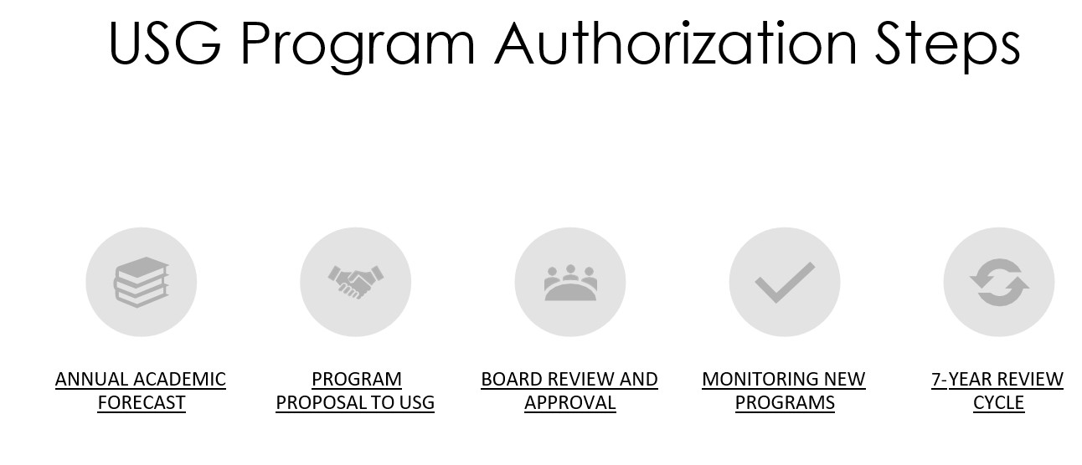

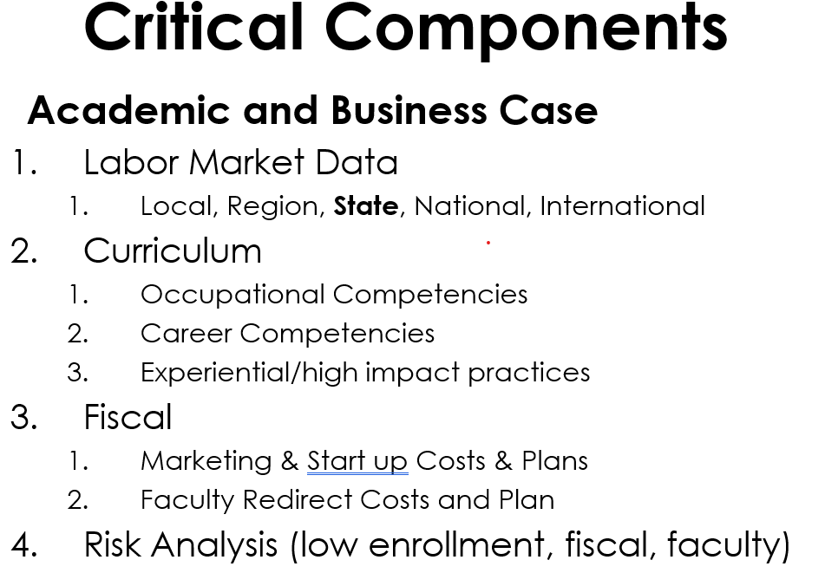
- Bonuses The USG announced today that all benefitted employees earning less than $80,000 per year will receive a $1,000 bonus. More information will follow next week.
Subcommittee on Nominations (SCoN) — Chair Catherine Fowler

- Election Oversight All faculty election results have been received.
  - COAS: Dr. Glotzbecker, Dr. Welborn, Dr. Flory, Dr. Trujillo
  - COB: Dr. Folk, Dr. Richardson, Dr. Ling, Dr. Creel
  - COE: Dr. Muschell, Dr. Cross
  - Library: Dr. Sanford
- At-Large Election Voting will occur from February 22 to February 26.
- University Senate on University Committees Committee continuations and vacancies will be reviewed in March.
- COVID Updates Presentation of Data Angie Childre, Interim Director of Student Health Services reports, “We have had 7 reported positive cases this week so far. Vaccines are not available at this time. This is what we are communicating with the campus community: ‘Georgia College has received approval from the Georgia Department of Public Health (DPH) to serve as a COVID-19 vaccine distribution site. We are awaiting further information from DPH on the timing and the allotment of vaccines we can expect. As soon as we have more information, we will communicate that to our campus community.’”

Executive Committee of University Senate (ECUS) — Chair Hauke Busch

- University Senate Budget No spending is anticipated for the university budget at the present time.
- University Senate Recognitions University Senate Recognitions (Certificates/Pins) Report has been generated and has been forwarded to President Dorman for final review and signing.
- Senate Representatives on University Committees A review of University-Wide Committees with Senate Representation is being planned to fill vacant positions once the election results of the new senators have been posted. Also, Senate volunteers, staff member, SGA, appointees, senate committee preferences, POE & secretary nominations, etc. requirements were discussed.
- Proposed Revisions to University Senate Bylaws (Diversity Committee) The motion is going to have its 2nd reading at the next senate meeting.
- Request for List of Course Sections The state legislator’s request for list of course sections was discussed during the meeting. A possible process for how to forward curriculum related information to legislators was identified and forwarded to be discussed with the SCC.
- Mental Health Initiative Dr. Shawn Brooks, Vice President for Student Life, will give the University Senate an update on mental health support services to our students.
- University Senate and IT Governance Susan Kerr, Chief Information Officer, is going to make an announcement on the “University Senate and IT Governance”, and the requirements for new senator designees.
  - One person to sit on the main Information Technology Council
  - One person to sit on the Academic Technology Advisory Committee
  - One person to sit on the Infrastructure and Security Advisory Committee
- ECUS-SCC Discussion
  - Proposed Revisions to University Senate Bylaws (Diversity Committee)
    - Comment: I am hesitant on the resource allocation of the standing committee vs the subcommittee. The dissolution of CAPC freed up senators to serve on more committees.
    - Comment: I suggest that we emphasize to Senate that the standing committee vs subcommittee options were discussed at length early in the process and ECUS decided to present the diversity committee as a standing committee after input from various stakeholders across campus.

Academic Policy Committee (APC) — Chair John Swinton

- Curriculum Request Procedure Report that the Chair initiated a conversation with the Provost about establishing a procedure for responding to general requests about the curriculum of courses. The Provost responded that the idea was worth pursuing.
- Pass/Fail Grades APC discussed the merit of introducing a policy allowing students to select a pass/fail option for select courses. A subgroup of members will attempt to draft a policy proposal with the help of the Registrar.
- ECUS-SCC Discussion
  - Pass/Fail Grades
    - Question: Have plus/minus grades been discussed? Answer (APC Chair): Yes, it comes up almost every year. We looked at it earlier this year. Committee members polled their constituents. There is no interest for this from faculty, or students after they realize that the system includes minuses. Comment: Pre-professional students are particularly concerned about how the minuses affect GPAs, i.e., the plus/minus scale tends to lower GPAs.
    - Question: Is there any concern that whole grades, as opposed to plus/minus grades, lead to grade inflation. Answer: We don’t remember the data.
    - Comment: As a point of information, the USG does not determine how institutions structure the grading scale. It varies across the system.
    - Comment: The more grade increments on the scale, the more likely students will be to campaign for higher grades.

Faculty Affairs Policy Committee (FAPC) — Chair Hank Edmondson

- Part-Time Faculty Pay The committee continues to examine adjunct pay.
- Student Rating of Instruction Survey There is discontent with the faculty evaluation system, particularly the participation rates. Faculty cajoling students to complete teaching evaluations with pizza or extra credit introduces conflicts of interest. The committee is interested in looking at the costs of the current system, such as licensing and staffing.
  - ECUS-SCC Discussion Follow Up: Hank Edmundson will contact former FAPC chairs Alex Blazer and David Johnson for a history of the current teaching evaluation system and software.

Resources, Planning and Institutional Policy Committee (RPIPC) — Chair Rodica Cazacu

- Online Proctoring Software Possibility of having a campus license for ProctorU. Susan Kerr informed us that there was an attempt to use Proctorio but everything was stopped because privacy issues. She also suggested that it may be possible to use an application that allows instructors to look down browsers while testing.
- Classroom Assignments Concerns and challenges instructors have this semester with/in assigned classrooms – the communication barrier. For large classes that meet in Russel Auditorium, Magnolia Room, Centennial side courts students stop asking questions because the instructor can’t hear/understand them well. This leads to them being frustrated and not attending the class.
- Security and Fire Safety Report Damian Francis mentioned his concerns about the latest security report, released in December 2020, not mentioning anything about the gas leaks in campus. He is concerned about not addressing the problem at all and presenting possible solutions together with an evacuation plan for these events as well as when threats are made by students.
- Ventilation Infrastructure question/concern from Damian Francis: What type of ventilation (purification) systems are installed in the campus buildings? Susan Allen says that purification filters were installed in all buildings.
Student Affairs Policy Committee (SAPC) — Vice Chair Diana Young for Chair Jamie Addy

- Mental Health Initiative Tom Miles, Dean of Students, shared information about the USG's new mental health initiative and Christie Campus Health, the 24/7 online student mental health support program that provides unlimited online support for all GC students.
- SGA Nathan Graham, SGA President, gave updates about various SGA goals, including the creation of a new master list of student support resources and services that any student can make use of.
- Student Advisory Committee on Diversity We also discussed the new Student Advisory Committee on Diversity, which is made up of over a dozen students from diverse backgrounds to provide input to Tom Miles (Dean of Students), Carolyn Denard (Chief Diversity Officer), and Nadirah Mayweather (Director of the Cultural Center) about the university's efforts to promote inclusive excellence across campus.
- Mental Health Resources as Required Syllabus Statement A suggestion was made to consider including information about GC Mental Health as syllabus statements.
- ECUS-SCC Discussion
  - Mental Health as Required Syllabus Statement
    - Question: What is the rationale for requiring a statement about campus mental health resources on syllabi? Answer: The issue was brought up by student representatives. Including mental health resources on syllabi would improve the visibility of the resources. Moreover, mental health affects academic well-being.
    - ECUS-SCC steered the item to APC.
    - Follow Up: It was suggested that Shawn Brooks, Vice President for Student Life, and Nathan Graham, SGA President, draft a two-sentence statement and provide a resource link for APC to review.

VI. Unfinished Business

- None

VII. New Business

- Steering of Items to Committees
  - Mental Health Resources as Required Syllabus Statement was steered to APC.
- University Senate Agenda and Minutes Review
  - Tentative Agenda 26 Feb 2021
    - Motions: There will be one motion on the agenda of this meeting of University Senate.
      - ECUS: Bylaws Revision
    - Reports: Administrative reports and committee reports will also be agenda items.
    - Supplemental Items of Business
      - Dr. Shawn Brooks, Vice President for Student Life will report on the Mental Health Initiative.
      - Susan Kerr, Chief Information Officer, will report on Information Technology Governance.
  - University Senate Minutes Review A Motion that the DRAFT minutes of the 22 Jan 2021 meeting of the 2020-2021 University Senate be circulated for university senator review was made and seconded. The motion to circulate the minutes was approved.
VIII. Open Discussion

- None
IX. Next Meeting

- Calendar
  - University Senate Meeting – Friday, February 26, 3:30 p.m., Webex
  - ECUS Meeting – Friday, March 5, 2:00 p.m., Webex
  - ECUS+SCC Meeting – Friday, March 5, 3:30 p.m., Webex
- Tentative Agenda Some of the deliberation today may have generated tentative agenda items for ECUS and ECUS-SCC meetings. Hauke Busch will ensure that such items (if any) are added to the agenda of a future meeting of ECUS or ECUS-SCC.
X. Adjournment

- As there was no further business to consider, a Motion to adjourn the meeting was made and seconded. The motion to adjourn was approved and the meeting adjourned at 4:15 p.m.
XI. Supporting Documents

- There are no supporting documents.
Distribution: First, these minutes will be sent to committee members for review; second, they will be posted to the Senate website.

Committee Name: Executive committee of the university senate (ECUS) with standing committee chairs (SCC)
Committee Officers: Hauke Busch (Chair), Catherine Fowler (Vice-Chair), Alex Blazer (Secretary)
Academic Year: 2020-2021

Aggregate Member Attendance at Committee Meetings for the Academic Year:
“P” denotes Present, “R” denotes Regrets, “A” denotes Absent
Acronyms |  | EFS = Elected Faculty Senator  CoAS = College of Arts and Sciences; CoB = College of Business; CoE = College of Education; CoHS = College of Health Sciences
Meeting Dates |  |  | 9/4 | 10/2 | 11/6 | 1/8 | 2/12 | 3/5 | 4/9 | P | R | A
Alex Blazer  EFS, CoAS, ECUS Chair Emeritus, ECUS Secretary |  |  | P | P | P | P | P |  |  | 5 | 0 | 0
Hauke Busch  EFS, CoAS, ECUS Vice-Chair |  |  | P | P | P | P | P |  |  | 5 | 0 | 0
Steve Dorman  University President |  |  | P | R | R | R | R |  |  | 4 | 1 | 0
Catherine Fowler  EFS, CoHS  ECUS Vice-Chair |  |  | P | P | P | P | P |  |  | 5 | 0 | 0
David Johnson  EFS, CoAS  ECUS Chair Emer. |  |  | P | P | P | P | P |  |  | 5 | 0 | 0
Karl Manrodt  EFS, CoB  ECUS Member |  |  | P | P | P | P | P |  |  | 5 | 0 | 0
Lyndall Muschell  EFS, CoE  ECUS Member |  |  | P | P | P | P | P |  |  | 5 | 0 | 0
Costas Spirou  Provost |  |  | P | P | P | P | P |  |  | 5 | 0 | 0
Jennifer Townes  EFS, Library  ECUS Member |  |  | A | P | P | P | P |  |  | 4 | 0 | 1
John Swinton  APC Chair |  |  | P | P | P | P | P |  |  | 5 | 0 | 0
Hank Edmondson FAPC Chair |  |  | R | P | P | P | P |  |  | 4 | 1 | 0
Rodica Cazacu RPIPC Chair |  |  | P | P | P | R | P |  |  | 4 | 0 | 1
Jamie Addy  SAPC Chair |  |  | P | P | P | R | R |  |  | 3 | 0 | 2

