**2019-2020 University Senate**

**Minutes for the 28 Feb 2020 Meeting**

*University Senate Officers: Presiding Officer David Johnson, Presiding Officer Elect Hauke Busch, Secretary Alex Blazer*

**Present (32)** Susan Allen, Alex Blazer, Kevin Blanch, Robert Blumenthal, Linda Bradley, Hauke Busch, Krystal Canady, Rodica Cazacu, Angela Criscoe, Nicole DeClouette, Steve Dorman, Matt Forrest, Brad Fowler, Catherine Fowler, Sarah Handwerker, Sabrina Hom, David Johnson, Monica Ketchie, Min Kim, Julian Knox, Alesa Liles, Catrena Lisse, Stephanie McClure, Renee Mosely, Lyndall Muschell, Christine Mutiti, Gennady Rudkevich, Joanna Schwartz, Costas Spirou, John Swinton, Ashley Taylor, Diana Young

**Absent (7)** Paulette Cross, Glynnis Haley, Amelia Lord, Bryan Marshall, Amy Pinney, Katie Stumpf, Cameron Watts

**Regrets (9)** Jamie Addy, Justin Adeyemi, Jeffrey Dowdy, Hedwig Fraunhofer, Claire Garrett, Leng Ling, Ben McMillan, Jessica Wallace, Jiaqin Yang

**Guests (9)**

|  |  |
| --- | --- |
| **Name** | **Role on University Senate or Position at the University** |
| A Kay Anderson | Assistant Vice President of Enrollment Management and University Registrar |
| Shawn Brooks | Vice President for Student Life |
| Shea Council | Administrative Assistant of the 2019-2020 University Senate |
| Carolyn Denard | Associate Vice President for Inclusive Excellence & Chief Diversity Officer |
| Nathan Graham | Student Government Association Senator |
| Maxwell Harley | Student Government Association Senator |
| Emily Jarvis | Director of Parent and Family Programs |
| Susan Kerr | Chief Information Officer |
| Ji Seun Sohn | Parliamentarian of the 2019-2020 University Senate |

**Call to Order**: David Johnson, Presiding Officer of the 2019-2020 University Senate, called the meeting to order at 3:30 p.m.

**Consent Agenda**: A consent agenda was available as an item of business listed on the meeting agenda and read as follows.

1. **agenda/minutes**
   1. University Senate Meeting Agenda (2/28/2020)
   2. University Senate Meeting Minutes (1/24/2020)

A **motion** *to adopt the consent agenda* was made, seconded, and approved by voice vote with no proposed extractions, no further discussion, no dissenting voice, and only voting members of the university senate eligible to vote.

**President’s Report — President Steve Dorman**

1. **Congratulations Dr. Hasitha Mahabaduge – USG Faculty Award Recipient** Congratulations to Dr. Hasitha Mahabaduge, Assistant Professor of Physics, who was recently awarded the 2020 Felton Jenkins, Jr. Hall of Fame Faculty Award for the University System of Georgia. Selected by a panel of faculty and administrators from across the University System, Dr. Mahabaduge was unanimously recommended as this year’s winner. The committee noted: “Dr. Mahabaduge has shown a commitment to mentoring his students while engaging them in every context from the classroom to applied, innovative research and community research. His college students carry their knowledge to area schools, for example, where they explain complex topics in such a way as to invite younger students to explore and learn.” Dr. Mahabaduge was recognized at the annual Regents’ Scholarship Gala on Friday, February 21, 2020, in Atlanta.
2. **USG General Education Project** 
   1. The USG *General Education Implementation Group* has completed its meetings. Dr. Tristan Denley presented at the February 11 meeting of the Board of Regents, and a link to his presentation can be found at [https://youtu.be/8E0x64jk8OE](https://nam03.safelinks.protection.outlook.com/?url=https%3A%2F%2Fyoutu.be%2F8E0x64jk8OE&data=02%7C01%7Ccostas.spirou%40gcsu.edu%7C1cd40b0b679347fc7db808d7b16614de%7Cbfd29cfa8e7142e69abc953a6d6f07d6%7C0%7C0%7C637172924306735991&sdata=kNRsF3X%2B4cjY9sabyjr2Tw1AHqyrd93It4NAIPJM03k%3D&reserved=0). The USG Redesigned General Education feedback portal can be found at: <https://www.usg.edu/redesigned_general_education/feedback>. Currently, there are three major elements in the proposed General Education Curriculum.
      1. Core Elements (33 Credit Hours) - Arts & Humanities, Math, History & Government, Social Sciences, Science, Data & Digital Fluency, Written Communication, and Oral Communication. 21st Century skills have been incorporated into these Core Elements and include: Critical Thinking + (Critical Thinking, Creative Thinking, Synthesis, Research, Problem Solving); Global Competencies (Culture & Diversity, Ethics, Global Perspectives, Citizenship); Information Literacy + (Information Literacy, Technology Skills, Data Literacy)
      2. Field of Study (18 Credit Hours)
      3. Exploratory Courses (9 Credit Hours)
   2. **If you have comments regarding the redesign, please submit them to the General Education feedback portal**. Prior to any redesign or reaction on our campus, we will await the finalization of project from Dr. Denley. We expect to hear more at the April or May Board of Regents meetings.
3. **Coronavirus Update** 
   1. The Department of Public Health is working closely with the CDC and state partners to prepare for a potential outbreak of COVID-19. In a news release dated February 26, they stated, “It is important to note that at this time, the overall risk of COVID-19 to the general public remains low.” The DPH urges the same measures that are used to prevent the spread of any respiratory virus to all Georgians:
      1. Wash your hands often with soap and water for at least 20 seconds. If soap and water are not available, use an alcohol-based hand sanitizer.
      2. Avoid touching your eyes, nose and mouth with unwashed hands.
      3. Avoid close contact with people who are sick.
      4. Stay home when you are sick.
      5. Cough or sneeze into your elbow or use a tissue to cover it, then throw the tissue in the trash.
      6. Clean and disinfect frequently touched objects and surfaces.
   2. DPH will continue to update Georgians through the website: <https://dph.georgia.gov/novelcoronavirus>. It is important to remember that the most accurate and timely information regarding this outbreak is available through DPH or the CDC’s website at <https://www.cdc.gov/coronavirus/2019-ncov/index.html>.
   3. Georgia College will continue to monitor guidance from the USG on this virus spread and will follow the lead of the USG on actions regarding any major decisions.
4. **Staff Salary Study** We are in the final stages of the staff salary study and focusing on three key areas: validation of the paygrades to be used; placement of existing positions within the paygrade structure; and the development of the philosophy standards and guidelines for application, to include an implementation strategy for future maintenance. We are hoping to implement the salary study changes in April 2020. The timing is governed by the need to receive salary guidelines from the system office and our internal budget development process.
5. **Traffic Crossings Update**
   1. We have had follow-up conversations with the Department of Transportation (DOT) regarding the status on two upcoming safety projects for GC, in addition to measures that we will take to improve safety on Montgomery Street. Specific details on each include:
   2. Weather permitting, DOT will start West Campus entrance improvements in March. DOT will share details of what to expect, and GC will message via FrontPage as well as other venue opportunities for campus. The improvement is called a Reduced Conflict U-Turn, and an example is provided in the following link:

[http://www.dot.ga.gov/DriveSmart/SafetyOperation/Documents/RCut/RCUT%20Brochure.pdf](https://nam03.safelinks.protection.outlook.com/?url=http%3A%2F%2Fwww.dot.ga.gov%2FDriveSmart%2FSafetyOperation%2FDocuments%2FRCut%2FRCUT%2520Brochure.pdf&data=02%7C01%7Cmonica.starley%40gcsu.edu%7C900e17bba0b04a3acd2a08d7bb99cc8e%7Cbfd29cfa8e7142e69abc953a6d6f07d6%7C0%7C0%7C637184141548295405&sdata=4hH2kZmyO%2BEV4%2FAb1XrWiCLlpQ8jII3l6FUAVFZgGLE%3D&reserved=0)

* 1. Once the West Campus entrance is completed, DOT will immediately begin work on safety improvements on Hancock Street. This project will include a new red-light safety feature at the Hancock and Clarke intersection which allows for a four-way stop of traffic to permit pedestrians on all corners to cross at the same time. Another safety system will be placed at the crosswalk on Hancock Street near Ennis to work in tandem with the intersection stop.
  2. We have been given permission by DOT to move forward with addressing safety measures on the state route at Montgomery Street institutionally. A study of the area is planned to ensure the proper improvements are put in place to address the traffic flow and pedestrian movement. This project will include improvements at the crosswalk on Montgomery Street between Beeson and Peabody as well as a safety measure for the intersection at Montgomery and Wilkinson Streets. GC will have oversight on these projects and continue to work through the process as quickly as possible to make the needed improvements.

1. **FY21 Budget Hearing** 
   1. Our annual Budget Hearing with Chancellor Wrigley and his staff will be held on Wednesday, March 25. Our approved agenda includes:
      1. Momentum Year – GC Journeys
      2. Budget Allocation Strategy
      3. Recommendations for Alternative Funding Model
      4. Potential nursing expansion
         1. Post-Baccalaureate Nursing Degree
         2. New Summer Nursing Cohort
      5. Andalusia Interpretive Center
      6. Old Courthouse Project
   2. The first two items are requests from Chancellor Wrigley, and the other items have been tailored to address areas of importance to our institution.
2. **Instructional Fee Phase Out** At the recent State of the University Address on February 7, I noted that I asked Ms. Susan Allen to develop a phased-in plan that would lead to removal of all **elective instructional fees** by the start of the academic year 2021-2022. These are typically course fees that are charged to the student to “resupply” for course delivery. This is an effort to keep the cost of higher education lower for our students and their families. Ms. Allen has historical data of the fees charged in each course and will create a pool from institutional fees that will be used to provide for the needs currently supplied by these fees. No department or college will be financially disenfranchised by this new process. Rather, the fees for courses will be requested from a central pool. Rules governing collection and use of the fee money will be followed.
3. **Campus Discussions** As a follow up to the State of the University Address, I will be visiting with faculty and staff across campus. I am hopeful to hear your feedback and clarify any concerns or questions you may have. I visited with with Staff Council on February 18 and with the College of Business faculty just prior to this meeting today. On March 4, I will visit with the Library faculty; and on March 23, I will visit with the College of Health Sciences. On April 3, I will visit with the College of Arts & Sciences and the College of Education. I am looking forward to the fruitful conversations and feedback regarding the future and the direction of the university.
4. **Dr. Robert E. “Buzz” Lee Room Dedication** On Saturday March 7, 2020, at 2:00, the family and friends of former Georgia College President Dr. Robert E. “Buzz” Lee will gather in the newly renovated Terrell Hall to celebrate his tenure at Georgia College (1956-1967). Dr. Lee was a passionate educator, leader and skilled communicator who led Georgia College during a transformative time. A portrait will be hung along with a plaque detailing his many successes during his time at Georgia College – including leading the transition to becoming a coeducational institution; admitting the first African American student, Ms. Celestine Hill; and establishing what is now the Georgia College & State University Foundation. As the new communications hub on campus, Terrell Hall is the perfect location to honor Dr. Lee due to his passion for maintaining dialogue with those with whom he had fundamental disagreements and searching for common ground wherever possible. Thanks to a generous donation from Dr. John Sallstrom, whom Dr. Lee hired in 1967, The Dr. Buzz Lee Civil Discourse Fund was established in 2018 to support student debate programs on campus.
5. **Russell Auditorium Upgrades** Russell Auditorium will be offline from May 20-August 5. The auditorium ceiling and balcony structures are being renovated to accommodate an upgrade in state-of-the-art lighting. This will improve the esthetics of our historic Russell Auditorium. This project will also include renovating the ceiling access walkway to improve safety measures.
6. **Policy Approvals** There were several policy changes in the last few weeks. The Facility Use Policy, Delegation of Contract Signature Authority Policy, and the Contract Management Policy were approved by the Executive Cabinet on January 27. The policies can be found at:
   1. Facility Use Policy  
      <http://gcsu.smartcatalogiq.com/Policy-Manual/Policy-Manual/Academic-Affairs/Academic-Policies-Procedures-and-Resources/Academic-Resources/Facility-Use-Policy>
   2. [Delegation of Contract Signature Authority Policy](https://nam03.safelinks.protection.outlook.com/?url=http%3A%2F%2Fgcsu.smartcatalogiq.com%2FPolicy-Manual%2FPolicy-Manual%2FCampus-Affairs%2FDelegation-of-Contract-Signature-Authority-Policy&data=02%7C01%7Cmonica.starley%40gcsu.edu%7C7cea7c38aa3543b62a5408d7b0c1380d%7Cbfd29cfa8e7142e69abc953a6d6f07d6%7C0%7C0%7C637172216230280141&sdata=esLgPsSUBbDfjE2IHrvQL4sHQzDpFSXjUQYgRvbL0pE%3D&reserved=0) <http://gcsu.smartcatalogiq.com/Policy-Manual/Policy-Manual/Campus-Affairs/Delegation-of-Contract-Signature-Authority-Policy>
   3. [Contract Management Policy](https://nam03.safelinks.protection.outlook.com/?url=http%3A%2F%2Fgcsu.smartcatalogiq.com%2FPolicy-Manual%2FPolicy-Manual%2FCampus-Affairs%2FContract-Management-Policy&data=02%7C01%7Cmonica.starley%40gcsu.edu%7C7cea7c38aa3543b62a5408d7b0c1380d%7Cbfd29cfa8e7142e69abc953a6d6f07d6%7C0%7C0%7C637172216230280141&sdata=deAQhAYCQc4tJ5D6EawlWcuqyxcy6gJJzpGIiH8ZUfE%3D&reserved=0)  
      <http://gcsu.smartcatalogiq.com/Policy-Manual/Policy-Manual/Campus-Affairs/Contract-Management-Policy>
7. **Thomas/Liberty Street Lot Opened** The Thomas and Liberty Streets parking lot is online. Once we have drier weather, the lot will be paved and permanently striped. Hopefully, this will occur during spring break or summer break. This lot adds 153 new parking spaces for the university.
8. **Groundbreaking/Ribbon Cutting** Last Friday, we had two exciting celebrations on campus. For the first time in ten years, Georgia College broke ground on a brand new campus academic facility. The groundbreaking ceremony for the new Integrated Science Complex took place at 11:00 a.m. in the future construction area on the corner of N. Wilkinson and W. Montgomery Streets. Later that day, we officially cut the ribbon to the newly renovated Terrell Hall. Thanks to each of you who were able to join us for these ceremonies. These two projects are testaments to the progress Georgia College is making on the path to preeminence.
9. **Legislative updated (Submitted by Johnny Grant, Director of Economic Development and External Relations)**
   1. Forty-five Georgia College students along with 12 GC faculty and staff visited the Georgia Capitol on Wednesday, February 26, for GC Day at the Capitol. The legislative activity featured a joint meeting of the House and Senate to hear the State of the Judiciary Address. At lunch, the students were able to hear from many GC alums about their jobs in state or federal government or with associations or businesses that interface with the Georgia General Assembly. They also learned more about internships available for those interested in pursuing public service.
   2. On February 25, six Georgia College students participated in the 2nd Annual GURC Posters at the Capitol exhibit. 43 posters representing 15 public and private colleges and universities were on exhibit for the legislators and general public present at the Capitol to view. Dr. Dee Sams and Ms. Robin Lewis spearheaded the creation and continuation of this project showcasing undergraduate research in our state.
   3. The legislative session is at its half way point, and the FY2020 Amended budget has been altered by the House and sent over to the Senate for their review. Work on the “big budget” for FY2021 is underway. While other legislation is being discussed, in the words of one legislator, “the budget is overshadowing everything else this year.”
10. **Save the Dates!**
    1. ***International Dinner***Saturday, March 7, 2020

6:30 p.m. – Magnolia Ballroom

* 1. ***President’s Spring Fling Faculty and Staff Picnic  
     Faculty and Staff Appreciation Night at the Spring Jazz Band Concert***Thursday, April 2, 20205:00 p.m. – Picnic with location TBD7:30 – Jazz Band Concert
  2. ***Celebration of Excellence***Friday, April 17, 20209:00 a.m. – Russell Auditorium
  3. ***Spring Graduate Commencement***

Friday, May 1, 2020

7:00 p.m. – Centennial Center

* 1. *Spring Undergraduate Commencement*

Saturday, May 2, 2020

9:00 a.m. and 2:00 p.m. – Centennial Center

1. **Questions** When President Dorman invited questions, three were forthcoming.
   1. **Terrell Hall** Question: Is Terrell Hall open? Answer: Yes, you can go in. There was a delay on the furnishings and moving faculty in, but all are encouraged to stop in and visit.
   2. **USG General Education Project** Question: On the matter of the USG core, the Implementation Committee completed its charge. Who can we give feedback tonow? Answer: My understanding is that there will not be another meeting of the Implementation Committee, much of the formulation and reformulation is occurring at the USG level. Dr. Tristan Denley would be glad to hear from you. If you have issues or concerns, let him know.
   3. **Campus Discussions** Question: Is there an agenda for your visit to the colleges? Answer: The visit is intended to share your visions and concerns. We will talk about whatever's on your mind.

**Provost’s Report — Provost Costas Spirou**

1. **General Education**
   1. We are currently in a holding pattern since policy language is under development (i.e., framework for each element of the core must be drafted).
   2. Regarding implementation date we are waiting for direction from the USG.
   3. Informational Meetings: Two or three regional meetings by the USG are currently under consideration.
   4. We expect to have more specifics at the April/May 2020 BOR meeting.

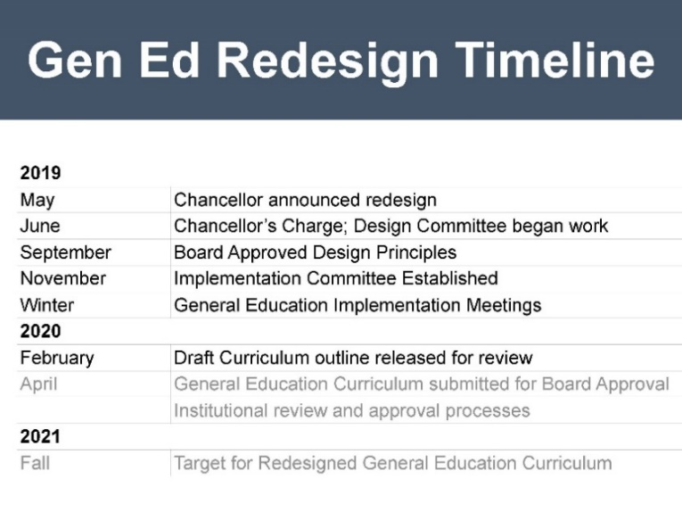

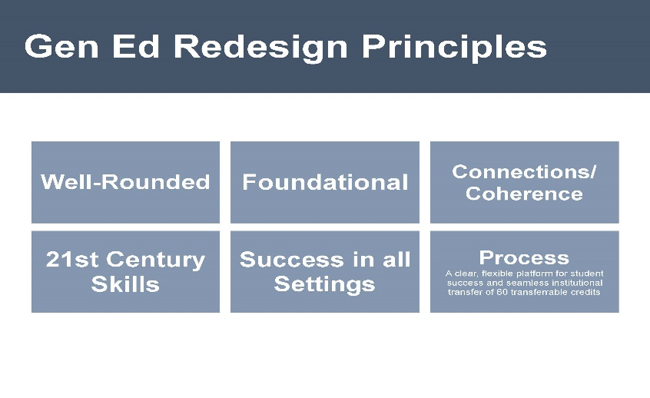



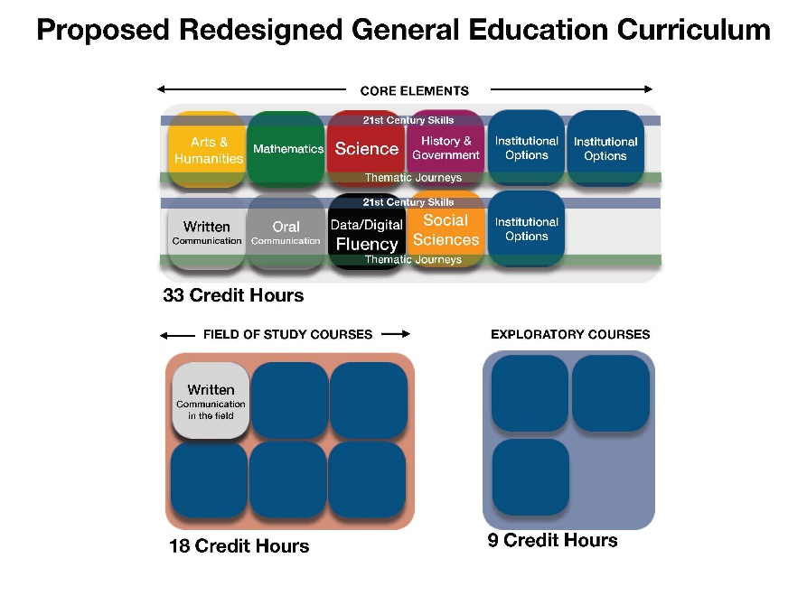

1. **Update – Momentum Summit-III**
   1. On January 28-29, the University System of Georgia held their 3rd annual Momentum Summit, asking representatives from each USG institution to participate. Georgia College’s Momentum Team included the President’s Cabinet, the Director of Advising, the Director of First Year Experience, the Director of GC Journeys, the Director of Residence Life, the Director of the Center for Teaching and Learning, and the Associate Provost for Transformative Learning Experiences.
   2. On Day 1, Dr. Jordan Cofer presented on *GC Journeys* and the use of Co-Curricular High Impact Practices. On Day 2, Dr. Cynthia Alby gave a presentation on GC’s use of faculty support for *GC Journeys*.
   3. During the two days, the GC team worked on issues to support GC’s Momentum Year plan, *GC Journeys*. The GC Team discussed ways to support faculty leading transformative learning experiences; creating advising touchpoints to support *GC Journeys*; ways to connect students with faculty during their first two years at GC; ways to help students choose experiences in *GC Journeys*; and finally, ways to document and track the experiences in *GC Journeys*.
   4. The GC team left with plans to follow up and continue finding ways to support faculty, staff, and students participating in *GC Journeys*.
2. **Inclusive Excellence Grants**
   1. The purpose of this Provost grant program is to provide funding for Georgia College faculty to conduct research on topics regarding inclusive excellence.
   2. The 2019-2020 recipients are: **Paulette Cross, PhD, Professional Learning and Innovation,** College of Education,*Capturing Family Backgrounds through the use of Oral Histories and Written Memoirs*; **Melanie Devore, PhD, Biological and Environmental Sciences,** College of Arts and Sciences,*Establishing and Researching the Impact of Traveling Trunks as a Tool for Earth Science Education of Edos (Georgia) and Tribal (Washington) in Rural Communities*.
3. **Guidelines from the USG on High Impact Practices**
   1. Earlier this month, the USG Academic Affairs Office provided insights and guidance about High Impact Practices. Specifically:
   2. The guidelines now state that campuses are to enter the appropriate High Impact Practice Banner code for all course sections that meet the institutional criteria as a HIP.  Previous drafts indicated that only course sections where all sections of the course met the criteria for a HIP should be entered into Banner as a HIP.  The revised guideline now includes course sections that include HIPs, even if other course sections of the same course do not include the same HIP.  As a result, institutions will need to approve individual course sections as HIPs, rather than only review courses where all sections include a HIP.
   3. The institution specific codes have been eliminated from the documentation. Institutions have always had the ability and option of adding additional Banner codes for courses.  As a result, it is unnecessary to specify system wide codes for institutionally specific attributes. Institutions that would like guidance on doing so are invited to contact System personnel to aid them in the process.
   4. For relevant HIPs, contact hour codes must be entered.  HIPs that include experiences outside the classroom (ex. work-based learning, service learning, etc.) will have contact hour codes that should be entered by the institution.
   5. A meeting is scheduled during the week of March 9th to gain input and support for next steps in expanding the implementation and scale of HIPs throughout the entire USG system.
4. **Novel Coronavirus** The USG provided information about the Novel Coronavirus on February 27, 2020 (available at <https://www.usg.edu/coronavirus>).
5. **College Visits**
   1. Visited the College of Education (January 17) and University Library (February 10); College of Arts and Sciences (February 21)
   2. Upcoming visits: College of Business (April 3), and College of Health Sciences (April 3).
6. **Honors College Dean Search Update** The Search Committee completed skype interviews and plans to bring the finalists to campus in early/middle part of March.
7. **Associate Provost and Director of the Graduate School Search Update** The Search Committee brought finalists to campus (February 14).
8. **Dovetailing of Real-World Experiences into Higher Education**
   1. Colleges and universities are engaging in the development embedded certificates and other micro academic experiences to connect students with real-world challenges.
   2. The USG is encouraging, and supporting such initiatives including the Nexus degree, the FinTech Academy, the Film Academy (University of Georgia-MFA in Film). All these emphasize the connections between industry, skilled knowledge and hands-on experience in high-demand career fields. Additional examples include USG Certificates in Blockchain with Machine Learning, Blockchain with Data Analytics, Cybersecurity, Film Production, etc.
   3. We are beginning to have more focused conversations about possible directions.
   4. What role can Continuing Education play in this process?
9. **Masters – 30 SH**
   1. Effective November 19, 2020, the BOR/USG passed the following policy: “Master degrees are comprised of 30 hours of a coherent program of study beyond the bachelor’s degree. Master degrees are subject to Board of Regents and USG policies on comprehensive program review and all relevant SACSCOC standards for a distinct program of study. Master degrees beyond 30 credit hours require the approval of the USG chief academic officer.”
   2. All current programs comprised of more than 30 cr. hrs. of degree requirements and were approved for the credit hour exception (i.e. 36, 45, 60 cr. hrs.) are “grandfathered” in under this new ruling. All new proposals for programs which exceed the 30-credit hour requirement, must also submit a request for an exception to 3.8.5 at the time of proposal consideration. Any program, that must undergo changes in credit hour requirements due to accreditation or professional certification/licensure standards, must submit these changes for notification (or in some cases re-approval) to the USG chief academic officer.
10. **USG Copyright Policy**
    1. Copyright: The University System of Georgia facilitates compliance with copyright law (<https://usg.edu/copyright>) and, where appropriate, the exercise in good faith of full fair use rights by faculty and staff. The main areas in which faculty come into contact with copyright decisions are using copyrighted materials in the classroom and on *GaView*, placing items on electronic reserve in the library, and within their own publishing endeavors. The first two areas are broadly covered under Fair Use.
    2. Fair Use: The determination of whether a use of a copyrighted work is within fair use depends upon making a reasoned and balanced application of the four fair use factors. Instructors are responsibly for determining whether the material they want to use falls under Fair Use. The Fair Use Checklist (<https://www.usg.edu/copyright/fair_use_checklist>) is an important tool in making that decision. Complete and retain a copy of this checklist for each “fair use” of a copyrighted work in order to establish a “reasonable and good faith” attempt at applying fair use should any dispute regarding such use arise.
    3. Best Practices for Electronic Reserves and Using Copyrighted Items in *GaView*:
       1. When possible, use a link for materials available through Galileo instead of posting a PDF.
       2. Complete and retain a copy of the fair use checklist for any items not found through Galileo or otherwise licensed by the University. (This is mandatory for placing an item on electronic reserve.)
       3. Include a citation to the original source of publication and a form of copyright notice.
       4. Materials must be lawfully obtained – use of materials, regardless of the source, without a clear statement providing permission to redistribute, violates fair use.
    4. Contact: Jennifer Townes ([jennifer.townes@gcsu.edu](mailto:jennifer.townes@gcsu.edu)) works closely with the Center for Teaching and Learning and is available for workshops, consultation, and training. For more information, please see the faculty guide at <https://libguides.gcsu.edu/authorservices>
11. **Library Acquisitions Timeline for FY21**
    1. ***Mid to Late March*** – Library liaisons will email departments with a list of current subscriptions.
    2. ***End of April*** – Departments will confirm subscriptions, new requests, and/or cancellations.
    3. ***May-June*** – Library will work with vendors to acquire resources, as needed.
    4. ***July 1*** – New resources will be available for use.
12. **Save the Dates!**
    1. ***Provost Faculty Appreciation Reception***Tuesday, April 21, 2020  
       5:00-7:00 p.m. – Heritage Hall
    2. ***Celebration of Faculty Scholarship and Grants***   
       Tuesday, April 23, 2020

**Committee Reports**

1. **Executive Committee of University Senate (ECUS) — David Johnson, Chair**
   1. **2020-20 Governance Calendar** ECUS approved the final draft of the 2020-2021 Governance Calendar, which will be made available to all on the university senate website.
   2. **Governance Retreat** Hauke Busch is in the process of reserving facilities at The Club on Lake Sinclair for the August governance retreat.
   3. **University Senate Representation on University-Wide Committees** All university-wide committee chairs that we reached out to indicated that committees such as the Academic Technology Advisory Committee, the Admin Systems & Banner Advisory Committee, the Parking Appeals Committee, the Public Art Committee did not necessarily need an elected faculty senator to serve on these committees, but that a faculty volunteer appointed by senate would suffice. Additionally, one member from senate on PTAC and the Mandatory Student Fee Committee could be a faculty volunteer as well.
   4. **USG General Education Project** There was open discussion regarding the ramifications of the USG’s gen ed redesign for our campus.
   5. **Faculty Searches** There were questions posed regarding whether or not Georgia College has a university-wide policy that stating that faculty searches should only cover one night of hotel expenses, rather than two.
   6. **President’s Commission on Diversity** We were informed at the most recent President’s Commission on Diversity meeting that the data from the recent Campus Climate Survey will soon be shared with President Dorman.
   7. **Budget** There was open discussion about using some of our carefully managed senate budget to purchase books about shared governance and other higher education trends. These materials could better inform us on many of the issues being driven by the Board of Regents.
2. **SubCommittee on Nominations (ScoN) — Hauke Busch, Chair**
   1. **Hemphill-Sallstrom Award Committee** It is anticipated that the Hemphill–Sallstrom Award Committee will require two faculty senator positions, to be determined sometime in March 2020. If you are interested, please let the POE know.
   2. **2020-21 Slate of Nominees**
      1. The Slate of Nominees for 2020-2021 is being finalized. Election results from Staff council are still being anticipated.
      2. We are still looking for a Presiding Officer Elect for the upcoming year. If you are interested, please let the POE know.
      3. University Senate Representatives for 2020-2021 have also been selected and the committee list is being finalized.
   3. **Governance Retreat**
      1. Reservations for Aubrey Lane are being processed for August 10 for the Governance Retreat and Organizational Meeting.
      2. 3-5 volunteers are sought after for the Governance Retreat Planning Committee. If you are interested, please let the POE know.
3. **Academic Policy Committee (APC) — Nicole DeClouette, Chair**
   1. **Academic Calendar Committee** As Chair of APC, Nicole DeClouette has requested representatives from across campus to serve on the Academic Calendar Committee.
   2. **Copyright and Fair Use Motions** APC is still working on the language and supporting documentation for three motions:
      1. To add University System of Georgia’s Copyright Policy (including the Fair Use Checklist) to Georgia College’s Annual Employee Compliance Training
      2. To add a paragraph about the copyright policy to the Georgia College's Required Syllabus Statements
      3. To add University System of Georgia’s Copyright Policy and Fair Use Checklist notification to the D2L/GeorgiaView splash page
   3. **Observance of Jewish Holidays**
      1. Chief Academic Officer Designee to APC and Chief Diversity Officer Carolyn Denard shared a concern raised by students that some faculty are not respecting students who miss class to observe Jewish Holidays. In some cases, students are penalized for missing class on those days.
      2. Since the Required Syllabus Statements already address the “Religious Observance Policy” (see below), Carolyn Denard will remind Deans and Chairs to remind their faculty about being tolerant of students missing class on the holidays. Also, there was a suggestion that we all, as senators, need to remind our constituents about this policy when we provide senate reports.
      3. “Religious Observance Policy, Syllabus Requirements” Students are permitted to miss class in observance of religious holidays and other activities observed by a religious group of which the student is a member without academic penalty. Exercising of one’s rights under this policy is subject to the GC Honor Code. Students who miss class in observance of a religious holiday or event are required to make up the coursework missed as a result from the absence. The nature of the make-up assignments and the deadline for completion of such assignments are at the sole discretion of the instructor. Failure to follow the prescribed procedures voids all student rights under this policy. (<https://gcsu.smartcatalogiq.com/en/Policy-Manual/Policy-Manual/Academic-Affairs/EmploymentPolicies-Procedures-Benefits/Faculty-Rights-and-Responsibilities/Faculty-Work-Requirements/Syllabus-Requirements>).
      4. “Student Absence Policy, General and Religious”: The interested reader will also note a complementary policy that provides further details as well as procedures related to the religious observance policy (<https://gcsu.smartcatalogiq.com/en/Policy-Manual/Policy-Manual/Academic-Affairs/Academic-Policies-Procedures-and-Resources/Academic-Policies-Miscellaneous/Student-Absence-Policy>).
4. **Faculty Affairs Policy Committee (FAPC) — Matt Forrest, Chair**
   1. **Meeting** FAPC did not meet of 14 Feb 2020 from 2:00pm to 3:15pm as there were no items of business requiring the attention of the committee, thus there is nothing to report.
5. **Resources, Planning, and Institutional Policy Committee (RPIPC) — Sabrina Hom, Chair**
   1. **25Live**
      1. We discussed a number of complaints and concerns about room assignments in 25Live, including concerns about classes assigned to rooms without needed technology or materials.
      2. University Registrar Kay Anderson points out that the list of room attributes on 25Live has deliberately been kept short, but that department chairs can request to the 25Live governance committee that technological devices (like document cameras) be added to the list.
      3. Departments that need spaces with very specific equipment or materials can request that the appropriate space be designated as a studio or lab. They will then be able to schedule classes directly in that space, bypassing 25Live. This request should come from the chair and go to the dean for approval.
      4. We discussed the committee's definition of flexible classrooms as classrooms with movable chairs, which is the most minimal definition. Some faculty, myself included, feel that this designation does not accurately reflect what is needed in flexible classroom space.
      5. Kay Anderson provided a training module that explains many of these procedures for any who are interested (see supporting document).
   2. **Adjunct Pay**
      1. We discussed compensation for part-time, limited term faculty, colloquially known as “adjuncts.”
      2. The chairs of Music and Theatre attended and pointed out that they have great difficulty hiring the needed faculty and this leads to problems for both the departments and the students. Nursing reported similar difficulties.
      3. No one can remember the last time that adjunct compensation increased; it has been the same for many years.
      4. Adjuncts were not included in the salary study, so we do not know how GC compares to other schools.
      5. It was pointed out that our adjuncts are often recruited from Atlanta or Athens, and that they usually have better options with an easier commute. Based on adjunct pay in my department, an adjunct diving down from Athens twice a week would not be paid enough to cover mileage. GC may need to pay more than schools in more accessible locations to attract quality adjuncts.
      6. There was some discussion of how this relates to the clinical faculty proposal, which is currently held up at the USG level.
      7. We felt that there was more to learn and discuss, but that was the end of our meeting period. ECUS recommends that this is more of a FAPC issue, so they will be taking it up in the future.
6. **Student Affairs Policy Committee (SAPC) — Angela Criscoe, Chair**
   1. **Crosswalks** Director of Public Safety and Chief of Police Brett Stanelle reports that Georgia College doesn’t own or control roads around campus. Hancock, Clarke, Montgomery owned and controlled by the Georgia Department of Transportation. Data on crosswalk usage has been requested, and upcoming meetings between GDOT and Georgia College Public Safety will determine how best to address problem areas.
   2. **Complaint Portal Interface** Director of Parent and Family Programs Emily Jarvis pulled up the portal and showed how one would submit a complaint. The entry page and user interface look more welcoming.
   3. **Diversity Town Hall** Student Government Association President Amelia Lord is considering scrapping the town hall because of hesitation from the Black Student Alliance and the Latino Student Alliance as well as the suggestion from the Office of Inclusive Excellence for Diversity Days with an educational component. Other key players that could support the diversity town hall include Alumni Association and President Dorman. The committee encouraged her to continue planning the town hall.
7. **Student Government Association (SGA) — Nathan Graham, President Elect, for Amelia Lord, President**
   1. **Regrets** President Lord sends her regrets.
   2. **Glass to Sand Machine** We have secured funds for bins to place around campus. There are bins in the residence halls. Deposits are judgment free. the only other university that has this program is the University of Hawaii.
   3. **Spirit Night at Barberitos** will take place Wednesday, March 4 from 6:00-9:00pm. 15% of proceeds goes to the Student Emergency Fund.
   4. **Bobcat Painting Thumbprints** will take place Monday, March 9 on Front Campus from 11:00-4:00pm.
   5. **Campus Wide Cookout** will take place on Saturday, April 25 from 1:00-4:00pm in the Sanford Parking Lot.
   6. **2020-2021 SGA Executive Board** Inauguration will take place Friday, May 15 at the Old Governor’s Mansion. More details and invitations to come.
      1. President: Nathan D. Graham
      2. Vice President: Samantha Cervantes
      3. Secretary: Margaret Owens
      4. Treasurer: Maxwell Harley
      5. Chief of Staff, Chief Justices, & President Pro Tempore will be announced at a later date.

**Announcements/Information Items**

* + - 1. **2020-21 Governance Calendar — David Johnson, Presiding Officer**
         1. David Johnson shared the final draft of the governance calendar that was approved by ECUS and highlighted Major changes from previous calendars. notably, New Faculty Orientation begins on a Tuesday instead of a Monday (Tuesday, August 4) and the Governance Retreat is on a Monday instead of a Tuesday (Monday, August 10).

1. **University Curriculum Committee (UCC)** **Update — Lyndall Muschell, Chair**
   1. **Action Items**
      1. Certificate – Leadership Studies – Approved
      2. Certificate – Asian Studies – Approved
         1. Note: *The Leadership Studies and Asian Studies Certificates are embedded undergraduate certificates which are awarded at the time the degree is earned. Students are not eligible to receive financial aid for the courses within the certificate unless the courses are a requirement of another degree. The certificates may not be awarded separate from a degree program.*
      3. Concentration – Forensic Chemistry – Approved
      4. Concentration – Data Science for Computer Science – Approved
      5. Concentration – Information Technology – Approved
      6. Concentration – Web Development – Approved
      7. Concentration – Information Technology for Computer Science – Approved
      8. Modification of Existing Major – Computer Science – Approved
   2. **Information Items**
      1. **College of Arts and Sciences**
         1. **New Course Proposals**
            1. CHEM 4410 Forensic Trace Evidence and Materials Analysis
            2. CHEM 4420 Forensic Drug and Biomaterial Analysis
            3. CHEM 4420 L Forensic Chemistry Laboratory
            4. GC2Y How to Change the World
         2. **Modification of Existing Courses**
            1. HIST 4940 Independent Study – Create a zero-credit hour option, Change the range of credit hours available from 1-4 to 0-4
            2. POLS 4611 Contemporary International Problems Remove POLS 2401 (Introduction to International Relations) as a prerequisite
      2. **College of Health Sciences**
      3. **New Course Proposals**
      4. NRSG 3855 Sexual Assault Nurse Examiner (SANE) Training
      5. NRSG 3850 BSN Remediation
   3. **Graduate Council** 
      1. The College of Business is now up to date on graduate faculty status.
      2. College of Education applications for graduate programs are up.
      3. Music Therapy will be moving from the College of Heath Sciences to the Music Department in the College of Arts and Sciences.
      4. The registrar is in the process of ensuring that the list of Degrees and Majors Authorized (DMA) for Georgia College is up to date.
   4. **General Education Committee**
      1. GC2Y History of Death and Dying – Approved
      2. GC2Y Global Problems in Infectious Disease – Approved

**Open Discussion**

David Johnson asked the group if there were any items for open discussion, but none were forthcoming.

**Adjourn**

1. **Attendance and the Sign-in Sheet** David Johnson requested that each individual present at the meeting sign the university senator attendance sheet or guest sign-in sheet on their way out if they hadn’t already signed in.
2. **Motion to Adjourn** A motion to adjourn was made, seconded, and approved. The meeting was adjourned at 4:32 p.m.

**Supporting Documents**

1. There is one supporting document.
   1. *Supporting_RPIPC_25Live_Academic_Scheduling_2020-02-28*