December 17, 2015

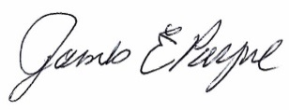
To: CAPC
From: James Payne, College of Business
Subject: Program Discontinuation
C: Academic Affairs, Costas Spirou

Discontinuation - Bachelor of Business Administration with a major in General Business

Upon the recommendation of the Department of Economics and the College of Business (CoB) Undergraduate Curriculum Committee CoB Dean James Payne recommends that Georgia College move forward with the immediate discontinuation of the General Business Major (BBA).

The Major in General Business has been deactivated since early 2011 because of poor productivity. The GC Registrar has confirmed that there are no more students in the program, thus we are now in a position to formally remove the major from the BoR program listing.

The CoB maintains a Minor in Business for non-business majors, thus GC students still have access to a course sequence that is similar to the BBA – General Business.

