March 20, 2008

MEMORANDUM

TO: Vice President Anne Gormly

FROM: Olufunke Fontenot, Assistant Dean, School of Liberal Arts & Sciences

SUBJECT: SoLAS Curriculum & Instruction Committee Actions Needing Further Review

The School of Liberal Arts & Sciences Curriculum & Instruction Committee met on March 12, 2008, to consider several proposals for changes in the curriculum. Among those considered and approved was a letter of intent to establish a new degree program, Bachelor of Arts in Geography. Doug Oetter presented the item at the meeting. The letter of intent is attached.

Dean Mike Digby and I have reviewed the proposal and approve same. I submit it to you now for further governance review and subsequent submission to the Board of Regents. With your approval, I will send it to the Curriculum & Assessment Policy Committee for review with copy to the Executive Committee of the Senate.

Thank you for considering our recommendation. Please call if you have any questions.

OF/alp

Letter of Intent to Propose a New Degree Program

Georgia College & State University

B. A. in Geography

Institution: Georgia College & State University Date: 5 March 2008
School/Division: School of Liberal Arts & Sciences
Department: History, Geography, & Philosophy
Name of Proposed Program: Bachelor of Arts in Geography
Degree: B. A. Major: Geography CIP Code: 45.0701
Starting Date: Fall 2009

Institutional Mission
- Does this program further the mission of your institution?
A Bachelors of Arts degree in Geography exemplifies the high attainment of our institutional mission, which has as its guiding principle the preparation of graduates who possess “an inquisitive, analytical mind; respect for human diversity and individuality; a sense of civic and global responsibility; sound ethical principles; effective writing, speaking, and quantitative skills; and a healthy lifestyle.” A well-rounded education in the holistic pursuit of geography directly addresses ‘respect for human diversity’ and a sense of ‘global responsibility.’ A geographic education, which reveals and explains global patterns of humanity and the environment, clearly supports these and many other stated outcomes of the Georgia College & State University mission. A geography degree would complement other programs within the university while providing strong support for the university mission.

- Will the proposed program require a significant alteration of the institutional mission?
The institutional mission supports the creation of a geography degree without any changes at all. In fact, one of the core characteristics of our mission is “a commitment to public service, continuing education, technical assistance, and economic development activities that address the needs, improve the quality of life, and raise the educational level within the university’s scope of influence.” With graduates in geography, our university can internationalize its curriculum and expand its reach across the globe, achieving substantial public service that improves the quality of life of countless citizens, both inside and outside Georgia.

- Will the program require the addition of a new organizational unit to the institution (e.g. college, school, division or department)?
The program will be housed in the existing Department of History, Geography, and Philosophy, within the existing School of Liberal Arts & Sciences. No institutional changes will be required.

- Is it likely that a SACS visit for substantive change will be necessary?
There is no reason to believe that SACS would need to review this program. Almost all of the proposed coursework has already been created and reviewed, and the existing Minor in Geography was favorably reviewed in 2004.

- How does the proposed program help meet the priorities/goals of your strategic plan?
The GCSU Department of History, Geography, and Philosophy is dedicated to providing students with “a working knowledge of past and place; an understanding of the connections of past and present; intellectual curiosity and enthusiasm for learning; an ability to conduct historical, geographical, and philosophical research, to examine and analyze material critically, and to communicate knowledge and ideas effectively; preparation for advanced study and professional careers in history or other occupations; and the capacity for lifelong learning and responsible participation as citizens of today's world.” A Geography degree supports this mission in countless ways, as evidenced by the proposed outcomes:

  - Extract and use geographical information including, but not limited to atlases, gazetteers, maps, and online sources.
  - Acquire and develop geospatial data and use those data to generate analytical maps, charts, and tables.
  - Develop and apply an understanding of geography at varying scales from global and regional to local, including the general and unique attributes of major countries and world regions.
  - Explain the major processes that shape the physical environment, and relate them to spatial patterns of weather, climate, landforms, and ecosystems.
  - Compare and contrast the major processes that influence spatial patterns of human population, culture, geopolitics, economics, and urbanization.
  - Assess and appraise the interactions between humans and their physical environment.
  - Demonstrate the use of geographic knowledge and techniques to interpret causes and synthesize solutions to past, present, and future issues.

These outcomes were written toward the standards approved by the National Council on Geographic Education, which are the widely-accepted national standard for geography.
Geography imparts knowledge of place, it instills intellectual curiosity, and it encourages lifelong learning for citizens of today’s world.

The proposed outcome of the Geography degree are in direct support of the University’s stated strategic directions, especially the following:
- Exemplary Undergraduate Learning Experience
  - Geography helps students ‘learn beyond the classroom’ as it teaches global affairs and promotes study abroad and international enrichment
- Acclaimed Academic Programs/Distinctive Schools & Departments
  - Geography fits well within the overall reputation of GCSU as the state’s ‘Public Liberal Arts College’ because geography is a holistic discipline encouraging students to consider a wide variety of scientific, social, and artistic perspectives in the advancement of global knowledge.
- Strong Partner for Creating a Better Community and State
  - Already the Department of History, Geography, and Philosophy at GCSU is deeply involved in advancing Middle Georgia agencies, organizations, and education systems. A degree program in Geography will allow more students to fulfill their Capstone experience by working on service learning projects that continue to benefit the local community.

The University System of Georgia has an initiative to “prepare students for their futures as citizens and leaders in a global environment.” Because geography is ideally suited to learn about the ‘rest of the world’ and how past, present, and future leaders have and will shape that world, the creation of a B. A. in Geography is very well suited to our institution and system strategic plans. In particular, the system’s first strategic goal seeks to improve and expand undergraduate education, especially with respect to citizenship and global learning. Geography teaches students the issues that will confront future leaders, from climate change and feeding a growing population to political struggles over scarce resources and loss of cultural diversity.

- Will this proposal require an addition or change in your institution’s strategic plan?
Georgia College’s strategic plan is under development, but a broad-based holistic education in geography can certainly play an important role in our efforts to offer an international curriculum that expands global awareness. As Georgia’s Public Liberal Arts University, we recognize that an advanced knowledge of the world around us is critical for leadership in the 21st century.

- Will the program require an increase in state appropriation within the next five years?
The program will require the addition of at least one faculty member, in the specialty fields of economic and urban geography. There is an opportunity to fund that line for FY09. If the program is highly attractive to our students, an additional position should be created within five years to place four full-time faculty members in the program.

- If this is a baccalaureate program, will you be asking for an exception to the 120 hour expectation or to the core curriculum?
The proposed degree requires 120 hours plus the requisite first-year academic seminar.

- Are there program delivery formats that will be new or different for your institution?
The program is very similar to existing majors within the same department. It will not require any significant changes to the delivery formats familiar to the department and school.

Need
According to the National Geographic/Roper Public Affairs 2006 Geographic Literacy Study:
- Only 37% of young Americans can find Iraq on a map—though U.S. troops have been there since 2003.
- 6 in 10 young Americans don't speak a foreign language fluently.
- 20% of young Americans think Sudan is in Asia. (It's the largest country in Africa.)
- 48% of young Americans believe the majority population in India is Muslim. (It's Hindu—by a landslide.)
- Half of young Americans can't find New York on a map.
The United States’ position as a global superpower comes with enormous responsibilities to have our students actually know something about the world in which they live. Recent topics such as globalization, terrorism, and cultural exchange are all geographically based. According to the Homeland Security Department’s Secure Borders and Open Doors Advisory Committee, “the United States simply cannot conduct effective diplomacy – public or otherwise – if our citizenry does not have an understanding of the people we are trying to influence.”
The study of geography imparts a solid foundation in the physical systems of the planet (landforms, climate, plant distributions, soils) along with the structures of human societies built over the centuries (cities, networks, religion, language, politics, pollution). Geographic education is much more than having students memorize maps; it involves helping students understand how space affects all our lives. Geographers contribute to countless agencies, organizations, institutes, and schools dealing with international issues, regional planning, environmental management, trade and tourism, cultural studies, and so much more. A foundation in geography is critical to Georgia College’s aspiration to “teach as if the world depended on it.” Our institution has “ dedicated ourselves to the proposition that all minds should be free - to travel across disciplines, across cultures, even across continents. We won't be surprised if our students change the world.” At both the local and the national level, to change the world, one must first know it. School-age citizens in the U. S. have demonstrated repeatedly that their knowledge of the world is insufficient to deserve the status of the world’s superpower.
Renowned geographer Harm de Blij warns us of the great social costs of a geographically illiterate population:
“It deprives young students of an early awareness of spatial relationships. It denies them an early exposure to maps and their uses. It engenders a geographic illiteracy that lasts into adulthood. It delays, perhaps permanently, their appreciation of global natural environments and their impacts on human societies. It defers their comprehension of the planet’s natural resources and the need for their judicious use and conservation.”
We need a B. A. in Geography at Georgia College & State University so that we can hold true to our promise to educate the leaders of tomorrow. The State of Georgia needs this program so that our graduates can help us all prepare for the powerful global transitions that are already affecting so much of our economic, social, cultural, and environmental status. The students of GCSU need the degree so that they can be competitive in an increasingly global workforce, which requires advanced spatial technology and a rich understanding of foreign cultures and economic patterns.
Geography and geo-spatial technology represents one of the most dynamic sectors for the twenty-first century. Currently, Georgia students who wish to pursue a bachelor’s degree in geography must attend schools in eastern or northern Georgia. Students from central and southern Georgia who wish to stay close to home as well as those from the Greater Atlanta region wishing to escape its congestion must find alternate fields of study if they attend GCSU. This is especially unfortunate given the exponential growth of the geo-spatial sector. Indeed, geotechnology is regarded as one of the top three growth sectors in the US economy along with nanotechnology and biotechnology. Employers, however, consistently stress their need for employees whose training goes beyond technology to include a broad understanding of geographic concepts and regional applications.
Additionally, geography is an excellent vehicle to further university goals of internationalizing the curriculum, expanding global awareness, and promoting study abroad. Geography, by its very nature, is a discipline that bridges the gap between social and natural sciences. Thus, it can complement existing programs throughout the university while helping students develop greater respect for the world and all its diversity.
The numbers of students interested in geography grows every year. Since 2002, when GCSU acquired a second full-time geographer, the number students declaring a Geography Minor has risen greatly. Of the 30 current minors, over half have stated that they would rather be working toward a B. A. in Geography. Five students have left GCSU in the past three years to obtain a geography degree at another institution. About half of our minors are History majors, within the same department. There are currently 219 history majors at GCSU, and upper-level history classes are consistently over the established class size, as majors struggle to get into courses required for graduation. The creation of a B. A. in Geography would serve the desires of the students and relieve pressures on other existing programs.

Students
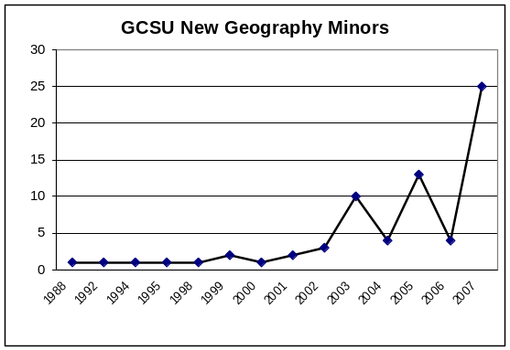
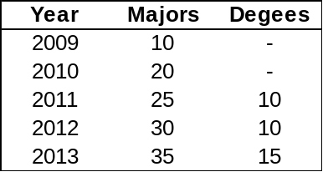
There are 5265 undergraduate students at GCSU, and 219 are History majors. Several of these students have expressed a desire to major in geography. There are also students from other degree programs who may prefer to study geography. We anticipate being able to recruit a minimum of five incoming students each year, along with another five students changing majors in each of the first two years. The students who switch majors will most likely come from the history degree; this transition will help that degree program alleviate overcrowding in its upper-level courses. By 2013, we expect to have 35 majors and graduate fifteen students each year.

Budget
1. Estimate the steady-state cost of the program (in current dollars) and indicate the percentages from reallocation, student fees, grants, and outside dollars.
A third full-time faculty position in geography has been proposed in the FY09 budget. If that position is funded, there should be minimal additional expense required to create this degree. Added expenses for departmental costs and library acquisitions can be funded through normal school and departmental operating costs. If the program is well-received by students, an additional full-time faculty member will be requested during the next five years.

2. Estimate start-up costs for the program and indicate possible fund sources.
The program will be housed in the existing Department of History, Geography, and Philosophy. There are no uncommon start-up costs for the program.

Facilities
No new or additional facilities will be required for the proposed degree program. The instruction and lab facilities are already in place within the Department of History, Geography, and Philosophy, and the School of Liberal Arts & Sciences. New requests for materials and equipment will be funded by departmental allocations and course lab fees.

Curriculum and Delivery
1. Are there special characteristics of the curriculum (as compared to similar programs)?
The curriculum will build on the National Geography Standards and will be closely attuned to similar programs in Georgia and other parts of the United States. Traditionally, geographers have been encouraged to develop at least one thematic specialty, one regional specialty, and skill in appropriate geo-techniques. This curriculum will modify that approach so that all graduates are exposed to elements of physical/environmental geography, human geography, regional geography, and geo-techniques. Once these requirements are met, students may concentrate their remaining courses in one of those fields or continue with a broad-based approach.

2. Will the program require new or special student services?
New or special services are unnecessary.

3. Will the program be attractive to underserved populations?
Existing degree programs are concentrated in the northern and eastern portions of the state. Central Georgia, which is traditionally more rural and less economically developed, lacks job training in geographic skills. A geography degree at GCSU will attract students who seek job opportunities in geospatial technologies, but wish to remain closer to home while they complete their studies.

Collaboration
The faculty have collaborated with programs around the state and the Southeast, but this collaboration does not go beyond academic engagement. The GCSU program will be independent and capable of offering a complete degree without significant assistance from outside the university.
- If there are similar programs in your service area, how will the proposed program affect them?
There are only five Bachelors degrees in Geography offered in the state (Georgia, Georgia Southern, Georgia State, Kennesaw State, and West Georgia). Valdosta State offers a degree in Environmental Geosciences, and Gainesville State has just developed a degree in Applied Environmental Spatial Analysis. Together these six degree programs graduated 66 students in 2006. There is no reason to believe that a B. A. degree in Geography at GCSU would negatively impact those other programs.

There is no other university in Central Georgia offering a geography degree. The nearest program (Georgia Southern) is 126 driving miles away. Central Georgia is underserved in geography, in spite of the fact that the Macon area is growing and has an established need for graduates in geography and geographic techniques.
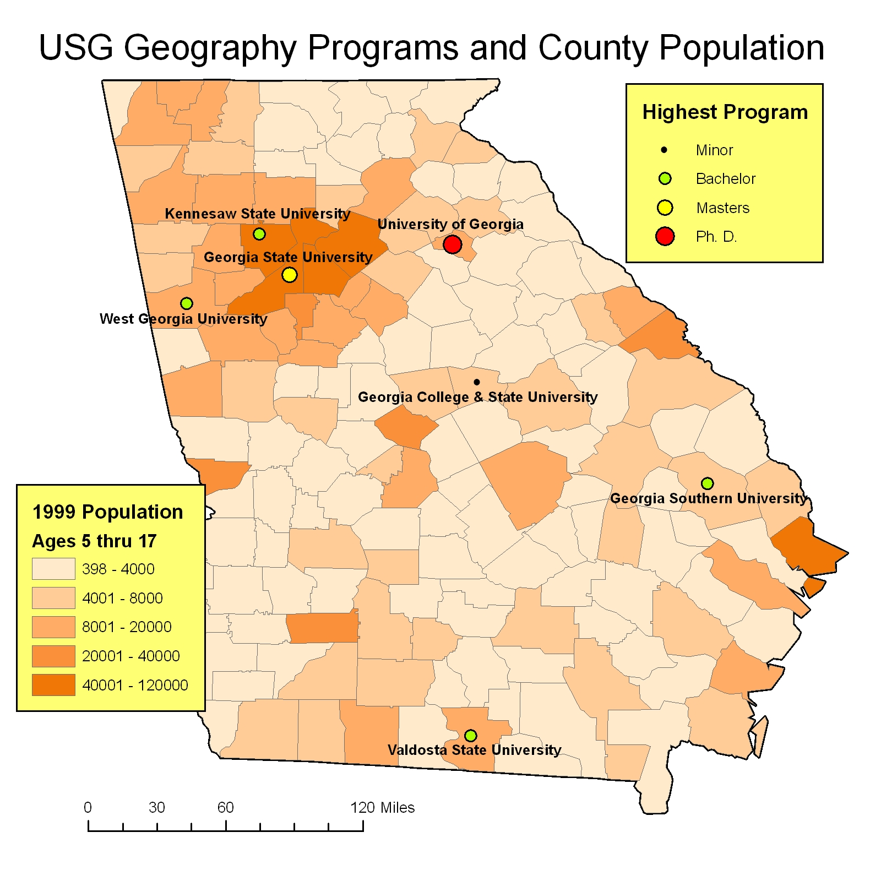
The demand for geographers is increasing, and the University System of Georgia should help develop more training opportunities for students who can obtain jobs in geographic fields. The U. S. Department of Labor Bureau of Labor Statistics reports that in 2006 there were 1,095 people with the job title ‘geography,’ and that total is expected to grow by 6.1% by 2016. This estimate is misleading, however, because graduates of geography programs obtain an incredible diversity of positions, rarely given the title ‘geographer’. For example, there are an additional 9,870 cartographers and photogrammetrists in the U. S., earning a median income of $46,080. Tens of thousands of other occupations are filled by geographers, including:
- Remote sensing specialists
- Surveyors and surveying technicians
- GIS analysts
- Urban and regional planners
- Business location specialists
- Earth scientists
- Social scientists
- Educators

- Do you plan a collaborative arrangement with another institution or entity?
There are no plans to collaborate with another institution or entity.

Other
The creation of a B. A. degree in Geography serves the best interests of the students, the institution, and the system by providing a liberal arts education that offers global knowledge and concrete job skills.

Endnotes

Georgia College & State University. Mission Statement. http://www.gcsu.edu/about/missionstatement.html.
Ibid.
Georgia College & State University Department of History, Geography, and Philosophy. Department Mission. http://www2.gcsu.edu/acad_affairs/coll_artsci/hist_geo/.
National Council for Geographic Education. The Eighteen National Geography Standards. http://www.ncge.org/publications/tutorial/standards/.
Georgia College & State University. Geographic Research at GCSU. http://hercules.gcsu.edu/~doetter/geo/research/index.html.
University System of Georgia. Strategic Plan. http://www.usg.edu/regents/strategic/.
Georgia College & State University. Strategic Focusing Initiative. http://www.gcsu.edu/administration/sfi/default.html.
Homeland Security Secure Borders and Open Doors Advisory Committee. 2008. Secure Borders and Open Doors: Preserving our Welcome to the World in an Age of Terrorism. Online at http://www.tia.org/resources/PDFs/Gov_affairs/SBODAC_Report_01_14_08.pdf.
Georgia College & State University. Mission. http://www.gcsu.edu/about/mission.html.
Ibid.
De Blij, Harm. 1999. Geographic Education and Public Policy. http://geography.about.com/library/misc/bldeblij1.htm.
Gewin, Virgina. 2004. Mapping Opportunities. Nature 427 (22 January 2004): 376-7.
Geography Education Standards Project. 1994. Geography for Life. Washington, D.C.: National Geographic Research & Exploration.
U. S. Department of Labor Bureau of Labor Statistics. Industry-Occupation Employment Matrix. http://data.bls.gov/oep/nioem/empiohm.jsp
Crosby, Olivia. 2005. Geography Jobs. Occupational Outlook Quarterly Online 49:1. http://www.bls.gov/opub/ooq/2005/spring/art01.pdf.

