Georgia College & State University
2013 Governance Retreat Report

Presented to:
Executive Committee of the University Senate – October 4, 2013
Standing Committee Chairs – October 4, 2013
University Senate - October 25, 2013

Planning Committee
Jan Clark – College of Arts & Sciences
Debbie Macmillan– College of Health Sciences
Lyndall Muschell- College of Education
Holley Roberts- College of Education
Monica Starley – Office of the President
Craig Turner – College of Arts & Sciences
Kathy Waers – Office of the President
Catherine Whelan – College of Business

Introduction
The 2013 Governance Retreat was held at Rock Eagle Conference Center, August 14, 2013. This report provides an overview of the planning process, details of the retreat organization, and an overview and evaluation of the retreat activities. Recommendations for future planning committees and governance retreats are also provided. Supporting documentation is included in the appendices.

Planning Committee Activities
January 2013
Lyndall Muschell agreed to chair the planning committee for the 2013 Governance Retreat. The committee was formed. (See above.) The initial meeting of the planning committee was held on January 28, 2013. The decision was made to explore an overnight event similar to the one planned for 2012. In addition, the committee made the decision to invite all members of the 2013-2014 University Senate committees (elected university senators, appointees, designees, and volunteers) rather than only university senators. Unicoi State Park and Amicalola Falls State Park were chosen as two venues from which to secure estimates. The dates for the event were determined to be August 14 and 15 to avoid conflicts with on campus events such as Assessment Day.

February 2013
The Governance Retreat Planning Committee secured estimates from the three locations listed below. Suggested locations were investigated to determine appropriateness of facilities, distance to venue, and estimated total cost. Estimates for the three locations ranged from $13,000 to $16,500. Unicoi State Park was selected as the venue to propose based on accommodations and cost. A budget including the costs of facilities, meals, and transportation was prepared for presentation to President Dorman for approval of the off-campus event. The following three locations were considered.
Unicoi State Park & Lodge - GeorgiaStatePark.org/Unicoi
Amicalola Falls State Park - GeorgiaStateParks.org/Amicalola Falls
Brasstown Valley Resort - www.brasstownvalley.com

March 2013
The budget for an overnight event, August 14 and 15, at Uncoi State Park was presented to President Dorman for his review.

April 2013
The committee was informed that due to budget constraints, an overnight retreat this year was not deemed fiscally responsible. The Planning Committee was asked to consider a one-day event and to suggest locations that were closer to campus. August 14 was selected as the date of the retreat with August 15 being an alternative based on availability. The following locations were initially suggested:
Cuscowilla (Lake Oconee) - http://www.cuscowilla.com/meetings.php
Ritz-Carlton Lodge (Lake Oconee)
-http://www.ritzcarlton.com/en/Properties/ReynoldsPlantation/Meetings
The Lodge (Lake Oconee) - http://www.thelodgeonlakeoconee.com/
Reynolds Plantation (Lake Oconee) - https://www.reynoldsplantation.com/
After investigating the sites, the Ritz-Carlton presented the only possibility based on space, distance, and catering. The estimate, however, was approximately $13,000 for the one-day event and, thus, was deemed cost prohibitive. The committee began exploring other alternative venues. Rock Eagle 4-H Conference Center http://www.rockeagle4h.org/ was offered as an alternative.

May 2013
A quote was received from Rock Eagle 4-H Conference Center, August 14 was confirmed as the date for the retreat, and a proposal was prepared and submitted to President Dorman for approval.

June 2013
Rock Eagle was selected as the location for the 2013 Governance Retreat. The official date of the event was determined to be Wednesday, August 14. All retreat invitees (elected university senators, appointees, designees, and volunteers) were asked to complete the interest survey in order to help finalize the proposed budget by securing numbers for catering and determining the feasibility of providing bus transportation to and from the Milledgeville campus. See Appendix A.

July 2013
The finalized contract from Rock Eagle was received and approved. The agenda of the retreat was discussed and planned. Members of the Planning Committee visited Rock Eagle. A tour of the facilities was provided. All arrangements relating to meeting rooms, set up, and catering were discussed. Bus transportation was confirmed. Online registration was created and opened to all retreat invitees. See Appendix B. A list of participants is provided in Appendix C.

August 2013
Arrangements for meeting rooms, set up, and menus were confirmed with Rock Eagle 4-H Conference Center. The agenda was finalized for the retreat. See Appendix D. The University Senate Handbook was compiled and sent to Printing Services. Representatives from the College of Business, College of Health Sciences, College of Education, College of Arts and Sciences, and the Library were asked to put together “door prize” packages to distribute at the retreat. Folders for participants were compiled which contained printed copies of the retreat materials. A list of these materials is provided in Appendix E. Digital copies are archived at http://info.gcsu.edu/intranet/univ_senate/Retreat_13/index.htm. The overall cost information is provided in Appendix F.

The 2013 University Senate Governance Retreat was held at Rock Eagle 4-H Conference Center on August 14. Below is a summary of sessions and the event evaluation.

Retreat Sessions
- Introduction to the University Senate: Structure and Purpose
- Breakout Sessions by Committee – Shared Governance and Responsibilities
- Committee Reports – Shared Governance and Responsibilities (A summary of responses from participants is provided in Appendix G.)
- Breakout Sessions by Committee – Operating Procedures and Review of 2013 Annual Committee Reports
- Policies and Procedures Training
- Welcome and University Updates – University President and Provost
- Program Prioritization Initiative- Update/Q&A
- Mock Senate Meeting – Cancelled due to extended Q&A (Appendix H)
- University Senate Social

Evaluation of the Retreat
An evaluation survey was created for inclusion in the retreat packets. A copy of this survey is included in Appendix I. The numerical results and comments from this survey are presented in Appendices J and K. The results of the survey suggest that the Governance Retreat was effective and well planned as a whole. Organizing breakout sessions by committee was viewed as being productive. Providing the printed handbook was reported as an effective and useful reference. The social time that was planned at the end of retreat was not formally evaluated but was well attended. The distance to the location and the venue were very positively evaluated, and the timing of the event seemed to fit well within other campus events.

Recommendations for 2014 Governance Retreat
Planning Committee
- Form Planning Committee by the end of the Fall semester 2013.
- Committee membership should include the Presiding Officer Elect and a representative combination of the following: faculty and staff, incoming/continuing senators, and a prior year committee member. The committee should be kept relatively small (4-6 members).
- Consult with members of previous year’s Planning Committee.
- Regularly report to ECUS via the Presiding Officer Elect or Planning Committee Chair.
- Continue the practice of inviting all members of the University Senate committees.
- Order folders and supplies needed for participant packets in the spring.
Location
- Solicit input on potential locations from invitees.
- Consider Rock Eagle as an option for next year.
- West campus was suggested as an option.
Date
- Identify a date that does not conflict with other university-wide events.
- Alternate overnight and one-day events depending on budget.
Registration
- Online registration for the retreat is an efficient way to obtain and track responses.
Retreat Agenda
- Review committee annual reports and prior retreat planning committee reports to identify relevant topics for sessions. Input from invitees can be obtained through a specific question on the retreat registration form.
- Provide opportunities for socialization as well as work sessions.
- Ensure that a significant portion of the session time is interactive with the opportunity to report back to the group.
- When using breakout groups for discussion, ensure that sufficient guidance is given regarding the purpose of the session.
- Continue to use the committee structure for breakout sessions. This enables discussion of operating procedures and tentative agenda items for the coming year.
- Even though the “mock” senate meeting was cancelled this year due to the extended Q&A session related to the Program Prioritization Initiative, consider its inclusion to allow committees to be introduced and report out.

Appendix A – Interest Survey

We are continuing to make plans for the 2013 Governance Retreat and need input from you. The retreat will be a one day event scheduled for Wednesday, August 14th . Tentative plans are to hold the meeting at Rock Eagle 4H Center beginning at 8:30 a.m. and concluding with an evening meal.

Please complete the survey at http://www.surveymonkey.com/s/F3YXJ66 by Thursday, June 13, even if you do not plan to attend. The primary purpose of this survey is to finalize the budget by securing numbers for catering and determining the feasibility of providing bus transportation from Milledgeville. Due to the location of the venue, we realize that many of you may wish to drive individually rather than travel as a group. However, due to the costs, individual travel reimbursements will not be made.

Also, if you have any ideas for session topics or issues for discussion, please include these on the survey form.

Further details regarding the retreat will be made available later in the summer.

Thank you for serving on the Georgia College University Senate.

Dr. Lyndall Muschell
Presiding Officer, University Senate
lyndall.muschell@gcsu.edu

Name:

I plan to attend the 2013 Senate Retreat on Wednesday, August 14.

( ) Yes
( ) No

I plan to travel to and from the retreat on the GC bus.

( ) Yes
( ) No

Suggestions for session topics or issues for discussion

Appendix B – Registration Form

2013 Georgia College Governance Retreat Registration

The 2013 Governance Retreat will be held on Wednesday August 14th at the Rock Eagle 4-H Center (Eatonton, GA). Please note that this is a full day retreat commencing with breakfast at 9am and concluding with an afternoon reception which should end by 4:45pm.

Registrant Information:
First Name*: ____________________________________________
Last Name*: ____________________________________________
Email Address*: ____________________________________________

1) Will you be attending the Governance Retreat? (Wednesday 8/14)*
( ) Yes
( ) No

2) Bus transportation will be provided from Milledgeville at no cost to retreat participants. The bus will depart at 8:30am and return to Milledgeville by 5:15pm.
Please note that if you choose to drive your personal vehicle to the retreat you will not be reimbursed for mileage.
Do you plan to use the bus transportation provided?*
( ) Yes
( ) No

3) Do you have any special dietary requirements?*
( ) No
( ) Vegetarian
( ) Vegan
( ) Gluten-free
( ) Other: _________________

4) Are there any particular sessions, topics, or issues you would like included on the agenda for the retreat?

Thank You!

Thank you for completing the 2013 Governance Retreat registration survey.

Additional information about the retreat will be available in early August.

If you have any questions about the retreat, please email senate@gcsu.edu

Appendix C – Retreat Participants

Appendix D – 2013 University Senate Governance Retreat Agenda

2013 University Senate Governance Retreat Agenda

Wednesday, August 14
All sessions will be held in the International Paper Building and/or the Hastings Building
at Rock Eagle 4-H Center
8:30 am | Bus departs Georgia College – Montgomery St. Shuttle Stop  Bus will be available to board at 8:15 am for a 8:30 am departure
9:15 am | Registration and Breakfast at Rock Eagle – Hastings Building
9:45 am | Welcome | Lyndall Muschell
 | Introduction to the University Senate: Structure & Purpose | Craig Turner
10:00 am | Breakout Sessions by Committee | Committee Chairs
11:15 am | Committee Reports | Lyndall Muschell
11:45 am | Lunch – Clover Room
1:00 pm | Breakout Sessions by Committee | Committee Chairs
1:45 pm | Policies and Procedures Training | Catherine Whelan
2:15 pm | Afternoon Break
2:30 pm | Welcome and University Updates | Steve Dorman  Kelli Brown
3:00 pm | Program Prioritization Initiative – Update/Q&A | Kelli Brown  Committee Chairs
3:30 pm | “Mock” University Senate Meeting | Lyndall Muschell
4:00 pm | University Senate Social
5:00 pm | Bus departs Rock Eagle 4-H Center
Approx.  5:30 pm | Bus arrives Milledgeville

Appendix E– List of Retreat Documents
(archived at http://info.gcsu.edu/intranet/univ_senate/Retreat_13/index.htm)

Retreat Agenda
A one page document of Orientation Highlights
Governance History
University Senate Handbook
2013-2014 Standing Committee Memberships
Shared Governance Session Questions
Shared Governance Article - Exactly What Is Shared Governance? by Gary A. Olson
Standing Committee Breakout Session Operating Procedures
Standing Committee Operating Procedures
Agenda of 14 August 2013 "Mock" University Senate Meeting
2012-2013 Standing Committee Annual Reports
- Academic Policy Committee (APC)
- Curriculum and Assessment Policy Committee (CAPC)
- Executive Committee of the University Senate (ECUS)
- Faculty Affairs Policy Committee (FAPC)
- Resources, Planning and Institutional Policy (RPIPC)
- Student Affairs Policy Committee (SAPC)
- Subcommittee on the Core Curriculum (SoCC)
Appendix F– Cost Summary

Vendor/Provider | Description | Amount
Rock Eagle | Accommodation, Meals, Meeting Rooms | $2040.00
Georgia College | Bus Transportation (Vehicle and Driver Costs) | $429.33
Printing Services | Copies and Handbook Binding | $162.00
Office Supplies | (no reimbursement requested) | .00
Planning Committee 2 Vehicles | (no reimbursement requested) | .00
Foundations Acct. (refreshments for social) | (no reimbursement requested) | .00
 | TOTAL | $2631.33
 | # Participants | 58
 | Cost per Participant | $45.37
Note that no reimbursement was requested for office supplies, mileage for planning committee vehicles or from the foundations account to support the social. This should be taken into account for next year’s planning.

Appendix G – Summary of Shared Governance Session Responses

What are your expectations for shared governance at Georgia College?
- Open communication and collaboration
- Shared knowledge and exchange of ideas through discussions
- Civility, professionalism, and respect
- Voice and input heard from all
- Transparent
- Willingness to change and compromise
- Become more aware of the university as a whole and understanding the process
- Serve as a conduit for stakeholders at the university
- Senate opinion is appreciated

What are your responsibilities as a faculty elected senator, volunteer, or appointee?
- Attendance and participation
- Hear voices and opinions of faculty and staff
- Being knowledgeable and prepared about the material being discussed
- Open Communication:
  - Inform yourself-read the information ahead of time
  - Inform your constituencies in time to give input
  - Communicating with the department or college about what goes on at Senate and subcommittee meetings
- Respect and represent the point of views of the constituents and your views

How will your committee communicate with the University community about the work it is doing?
Specifically, what is your role in this process of communication?
- Keep things in a positive light
- Open lines of communication
  - Use GC communications or send personal callouts for important information for the different colleges
  - Communicate information to the Deans
  - Provide letter updates
  - Record and post minutes
  - Always check emails
  - Updated website
  - Help each other with making sure all information is addressed and sent out
  - Put name to face with other faculty that will be helping
  - Share agenda points
- Report at department meetings
- Share our voices in department and college meetings
- Be observant and good listeners
- Make sure people know that their concerns are being addressed
- Welcome questions and dialogue from the Senate

How can your committee engage the university community in shared governance?
- Senate updates
- Hosting different forums
- Faculty social events
- Stay enthusiastic
- Pay attention to procedures and changes
- Train and refresh ourselves to be champions
- Agendas for upcoming senate meetings need to be sent to the entire community with link to “active motions”
- Help new faculty understand shared governance responsibility
- Orientation for new faculty
- Listen to faculty and student concerns, bring those concerns to the committee, act on decisions that are made, and report back
- Be informed and engaged
- Promote University Senate

Appendix H – Agenda for “Mock” University Senate Meeting

Agenda for “Mock” University Senate Meeting
Wednesday August 14th at 3:30 pm
Location: Rock Eagle 4-H Center, Hastings Building
- Call to Order
- Approval of Agenda
- Committee Reports
- ECUS / ScoN
- APC
- CAPC / SoCC
- FAPC
- RPIPC
- SAPC / SGA
- President’s Report
- Provost's Report
- Unfinished Business
- New Business
- Information Items
- Adjournment

Calendar
ECUS next meeting: Friday, August 23th, 2:00-3:15pm, Parks 301
Standing Committees next meeting: Friday, August 23th, 2:00-3:15pm, Locations TBD
Officer Training: Friday, August 23, 3:30 -4:45, Parks 301 (Secretaries – Locations TBD)
University Senate next meeting: Friday September 13, 2:00-3:15pm, A&S 272

Appendix I – Evaluation Form

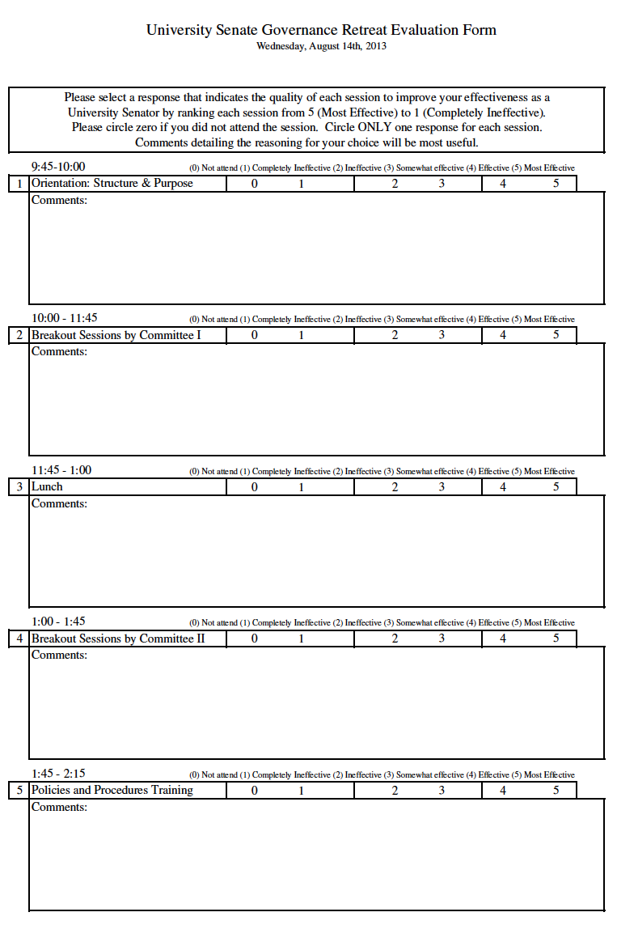

Appendix J – Evaluation Ratings

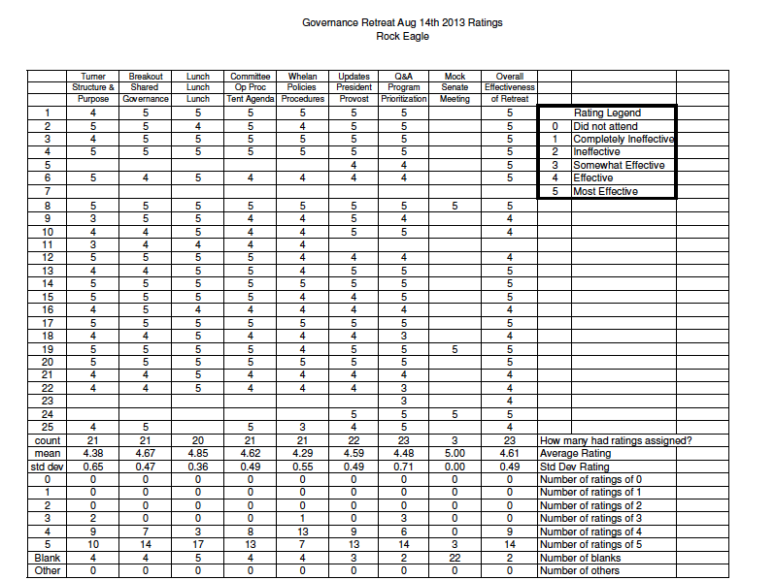

Appendix K – Evaluation Results: Comments

1. Orientation: Structure and Purpose
- Thank you to all who have served and made preparation for the ongoing success and responsibility this opportunity to serve others provide
- Good session
- It was hard to hear people talk with air conditioning running. Why not have the retreat at West Campus?
- Very well planned!!
2. Shared Governance Breakout (Committee Breakout Session I with Report Outs)
- Excellent use of time management for committee, very productive
- Good opportunity to organize committee work
- I thought the breakout sessions were very helpful.
- Enjoyed meeting my group.
- This was extremely helpful once we met as a new group and this was my first year on this committee as an officer.
3. Lunch
- Very good.
- Outstanding
- Lunch was excellent!
- Lunch (food in general) was wonderful. I felt we spent a lot of time eating.
- Yummy!
- Very tasty!
- Very nice!
4. Operating Procedure and Tentative Agenda Items (Committee Breakout Session II)
- More detailed discussions and agenda formulation for upcoming meeting.
- Good opportunity to set agenda
- I thought the breakout sessions were very helpful.
- Helpful.
- This was extremely helpful once we met as a new group and this was my first year on this committee as an officer.
5. Policies and Procedure Training
- The handbook is very effective and useful
- The handbook is very useful tool & refresher. It helps to get feedback from others who have served. Helps with continuity of processes.
- Good description and help
- Loved the brevity.
- Thankful she referred us to the templates and pages in the handbook!
- Might be useful to get some more specific examples, but the procedures book is excellent. I gave a 3 here because we were shorted on time, but also the format of reading to the audience from the manual isn’t the most effective (but again, I understand we were short on time, and it is difficult to do a training for a mix of veterans and newcomers).
6. Welcome and University Updates (President and Provost)
- Great opportunity to interface with President and Provost
- Great to hear what is in the works.
7. Program Prioritization (Update / Q&A)
- Good review for process
- Informative
- Helpful, overall feel people should understand to go to website.
- Hard to hear. What is data? Data is an abstraction. Students are reality.
8. Mock University Senate Meeting
- Note, this session was canceled due to the lively and productive discussion with President and Provost.
- Did not have but discussion with President Dorman & Provost Brown was well worth it!
- N/A
9. Overall Effectiveness of the Retreat
- Very informative for first-timers
- The committee meetings were very productive
- Good
- Great!
- Great job!
10. Feedback Scheduling (Dates, Times) (Travel, Refreshments) Location (Site)
- I liked the location much better than Callaway Gardens b/c of family commitments. The food was good!
- Excellent location – facility was conducive for break-out sessions and convenient dining facilities. The food was excellent.
- Excellent comfortable location – not too far but still relaxing and picturesque.
- The retreat was extremely organized and effective; very informative.
- Scheduling good, Travel/Refreshments great, Location great
- Satisfactory
- Great location.
- Scheduling excellent, Travel/Refreshments excellent, Location excellent
- Excellent!!
- Good not too far away! Date didn’t conflict too bad. ?Maybe 2.5 day retreats?
- Good job.
- Afternoon’s time was cut off so maybe that schedule needs to be re-evaluated.
- Great site
- Nice place.
- The schedule worked for me personally. I liked the fact that it was one day – or it could have been two on campus, but not an overnight trip because I have two small children at home. Thanks for providing the bus! The refreshments were delicious if not a little too abundant. Rock Eagle is a very nice location. I found it a little difficult to hear the speakers in the large room, but that might be handled easily with a microphone. I would recommend going back!

